C# Call by Reference

C# provides a **ref** keyword to pass argument as reference-type. It passes reference of arguments to the function rather than copy of original value. The changes in passed values are permanent and **modify** the original variable value.

**public** **void** Show (**ref** **int** val)

        {

             val *= val; // Manipulating value

            Console.WriteLine("Value inside the show function "+val);

        }

     In Main

**int** val = 50;

program.Show(**ref** val);

# C# Out Parameter

C# provides **out** keyword to pass arguments as out-type. It is like reference-type, except that it does not require variable to initialize before passing. We must use **out** keyword to pass argument as out-type. It is useful when we want a function to return multiple values.

public int ManipulateValue(out int Value)

{

Value = 4;

Value *= 5;

return 5;

}

In Main

Console.WriteLine(example.ManipulateValue(out Number)); //same as ref

Nullable:

Use of question mark

string? str=Console.ReadLine();//it can be null (Nullable)

Nullable<string> str=”s”;Console.WriteLine(str);

ToRead Float value from input: (No ToFloat function)

float f=Convert.ToSingle(Console.ReadLine());

Upcasting:

Animal animal2 = new Dog();

Downcasting:

Animal animal1= new Dog();

Dog dog1 = (Dog)animal1;

**Structs are implicitly sealed therefore they can't be inherited but it can implement interfaces.**

C# Extension Methods

C# allows us to create and **add new methods to existing class** without creating a new child class.

The existing class does not require recompiling the code. Static class.

C# extension methods are the special type of the static methods that can be called as instance methods.

* An extension method should be a **static method.**
* It must have **this keyword** associate with class name.
* The class name should be the first parameter in the parameter list.

<https://www.javatpoint.com/csharp-extension-methods>

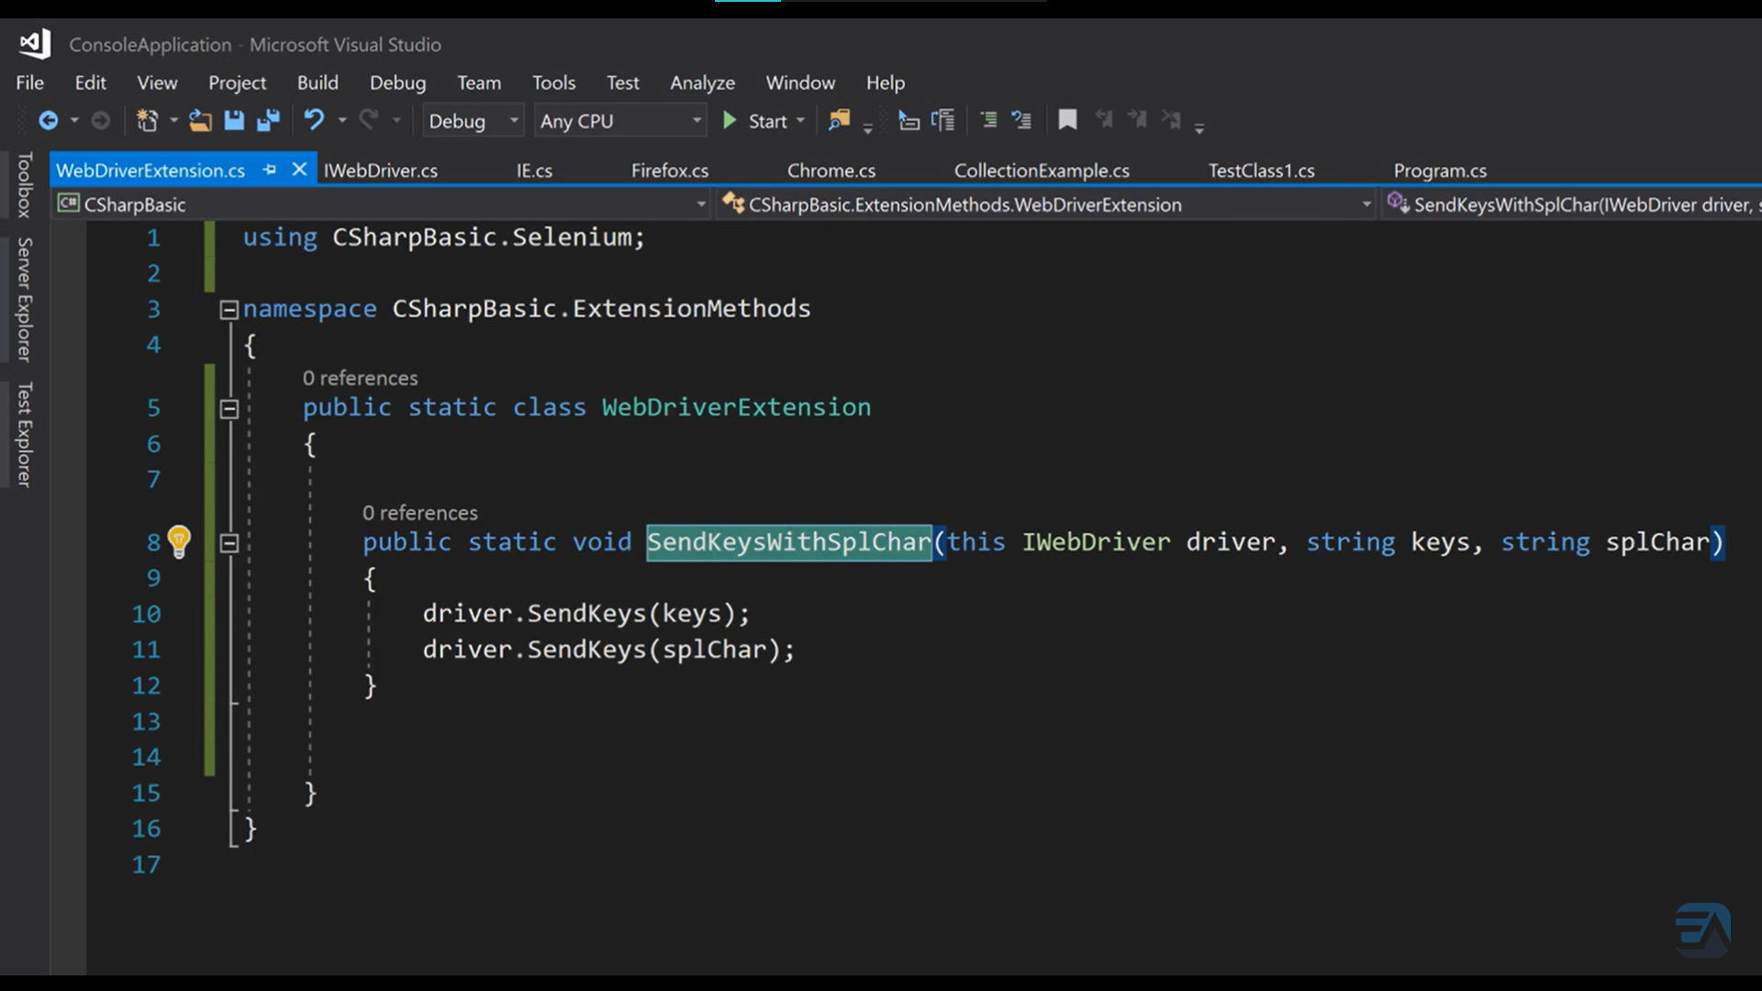

C# Partial Classes

Partial classes help split the methods into two or more source(.cs) files. All the partial classes will be combined when the whole program is compiled.

It can break the functionality of a single class into many files. When the application is compiled, these files are then reassembled into a single class file. The partial keyword is used to build a partial class.

C# Partial Method

Partial method is a special type of method which is declared and defined in two separate partial classes.

Declaration part represents signature and presents in a partial class.

The definition part provides implementation of the method and resides in separate partial class.

The concept of partial method is helpful when we have declaration and definition of method in two separate files.

If definition (implementation) of method is not provided, compiler removes the signature at compile time.

There are some **rules and restrictions** apply to the partial method.

* The signature of partial method must be same in both partial classes.
* The partial method must return void.
* No access modifiers are allowed like virtual, override, sealed, new or extern.
* Partial methods are implicitly private and can have static and unsafe modifiers.

The Partial modifier is not available on delegates and Enumeration declarations.

Partial 🡪 class, struct, interfaces.

(var) Implicitly Typed Local Variable

The **var** keyword can be used in following context.

* To create local variables inside a method block.
* In loop construct to initialize variable (foreach).
* In using statement to store resource reference.

The **var** keyword has following restrictions.

* It should use to declare and initialize local variable in the same statement. Ex. var a = (a=220);
* It cannot be used to declare class variables.
* It cannot be used to initialize multiple implicitly typed variables in the same statement.
* var d=1.2; (allowed)

<https://www.javatpoint.com/csharp-object-and-collection-initializer>

Operator Overloading

 Overloaded operators are functions with special names the keyword **operator** followed by the symbol for the operator being defined.

public static Box operator+ (Box b, Box c) {

Box box = new Box();

box.length = b.length + c.length;

box.breadth = b.breadth + c.breadth;

box.height = b.height + c.height;

return box;

}

Destructor: (Finalizer)

C# destructor cannot have parameters. Moreover, modifiers can't be applied on destructors.

    ~Employee()

        {

            Console. WriteLine("Destructor Invoked");

        }

Indexers and Destructors can’t be static.

**typeof**(Dog).IsSubclassOf(**typeof**(Animal)) //to check whether it is derived type

IsSealed,IsAbstract, IsSerializable, IsInterface, IsPublic etc

### Static methods only access static data members, they cannot access non-static data members in the class.

You can’t create static, readonly variables inside static methods, but you can use static class member created outside the method.

We can create local, const variables inside static methods.

Common functionality, Occurs only once (executes constructor only once), memory save, which does not associate with object ex: Utility, Helper classes

### Points to remember for C# static class:

* C# static class contains only static members and static methods.
* C# static class cannot be instantiated.
* C# static class is sealed.
* C# static class cannot contain instance constructors.

# C# static constructor

* C# static constructor is used to initialize static fields.
* It can also be used to perform any action that is to be performed only once.
* It is invoked automatically before first instance is created or any static member is referenced. Static constructor will be invoked only once i.e. at the time of class loading.
* There can be only one static constructor in a class
* C# static constructor cannot have any access modifier or parameter and invoke implicitly.
* Static Constructor cannot be inherited and overloaded.

Ex: static ClassName(){}

Static method is called when it is explicitly called by the user

A static constructor in C# is called automatically by the .NET runtime, and it is triggered under certain conditions. The exact timing can be summarized as follows: (automatic trigger, Thread safety)

1. **Before Any Static Members Are Accessed**: The static constructor is called before any of the static members of the class are accessed. This includes static fields, properties, methods, or events.
2. **Before Any Instances of the Class Are Created**: Although a static class cannot be instantiated, for non-static classes with static constructors, the static constructor is invoked before the first instance of that class is created.

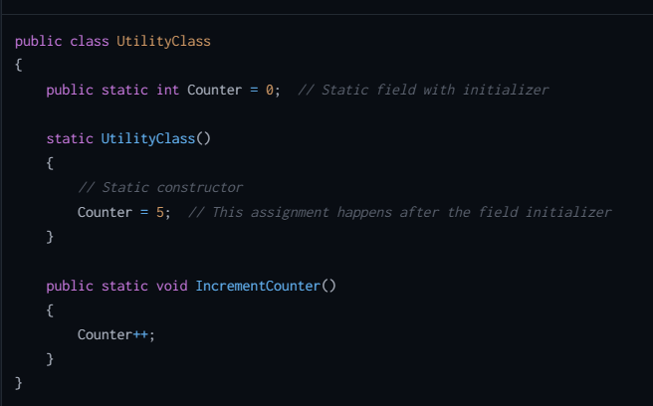

First initialization of counter to 0 happens then constructor executes at the time of class loading. Static method is executed when it is called

**Restrictions on Properties:**

* **A property cannot be passed via ref or out parameter to a method.**
* **You cannot overload a property (we can’t use multiple get and set methods in one property)**
* **A property should not alter the state of the underlying variable when the get accessor is called.**

**Only get means it should initialize value only in constructor;**

**Init: can be defined value in constructor and through Object initializers**

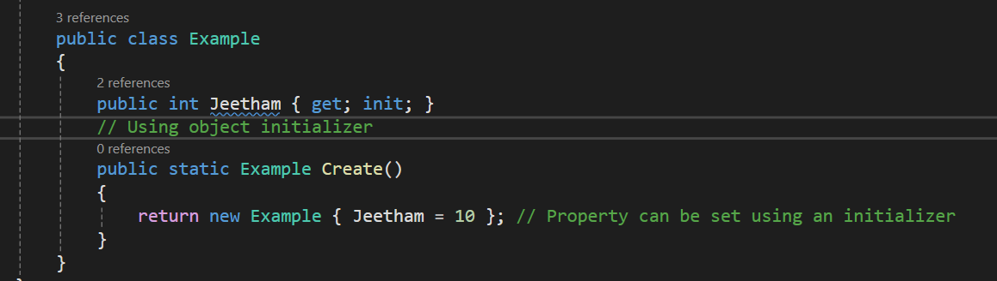

Boxing:

* The process of converting a [Value Type](https://www.geeksforgeeks.org/c-data-types-2/) variable (char, int etc.) to a [Reference Type](https://www.geeksforgeeks.org/c-data-types-2/) variable (object) is called Boxing.
* Boxing is an implicit conversion process in which object type (super type) is used.
* Ex: int num=9;

Object obj=num;

Unboxing:

* The process of converting a [Reference Type](https://www.geeksforgeeks.org/c-data-types-2/) variable into a [Value Type](https://www.geeksforgeeks.org/c-data-types-2/) variable is known as Unboxing.
* It is an explicit conversion process.
* Ex: Object obj =9;

int num=(int)obj;

Data Types:

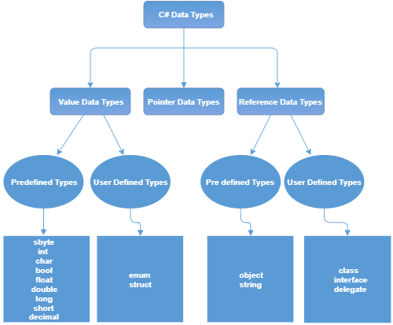

**Nullable**

**dynamic**

**recordArray**

**A**

**Array**

&🡪address  
*🡪Indirection

* **The Value Data Types** will directly store the variable value in memory and it will also accept both signed and unsigned literals. The derived class for these data types are **System.ValueType**.

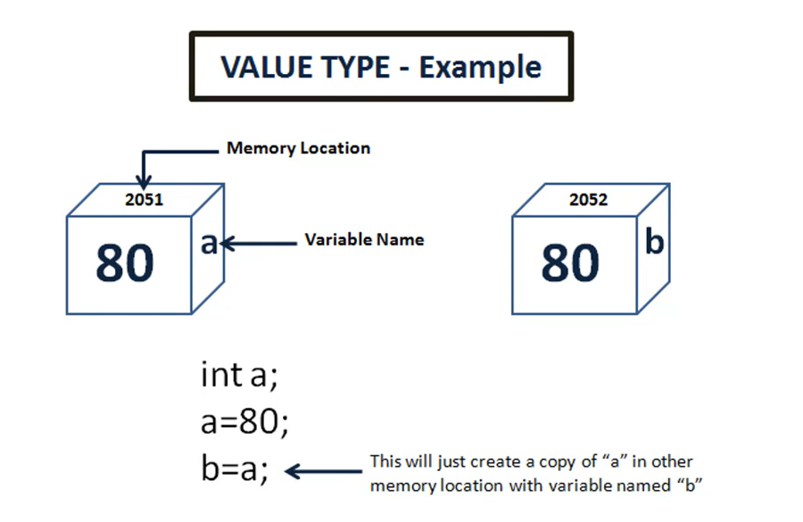 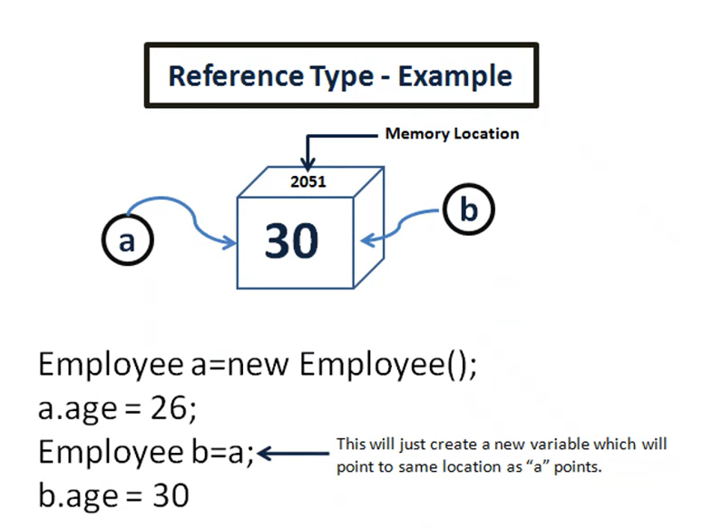

* **The Reference Data Types** will contain a memory address of variable value because the reference types won’t store the variable value directly in memory.
* **The Pointer Data Types** will contain a memory address of the variable value.

**You use the following operators to work with pointers:**

* Unary & (address-of) operator: to get the address of a variable
* Unary * (pointer indirection) operator: to obtain the variable pointed by a pointer
* The -> (member access) and [] (element access or index) operators
* Arithmetic operators +, -, ++, and --
* Comparison operators ==, !=, <, >, <=, and >=

[C# Strings - javatpoint](https://www.javatpoint.com/c-sharp-strings)

[C# Array Class - javatpoint](https://www.javatpoint.com/c-sharp-array-class)

[Defect Management Process in Software Testing (Bug Report) (guru99.com)](https://www.guru99.com/defect-management-process.html)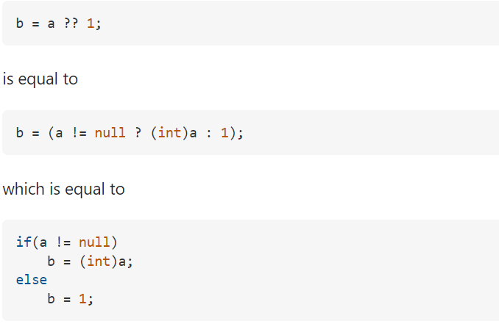

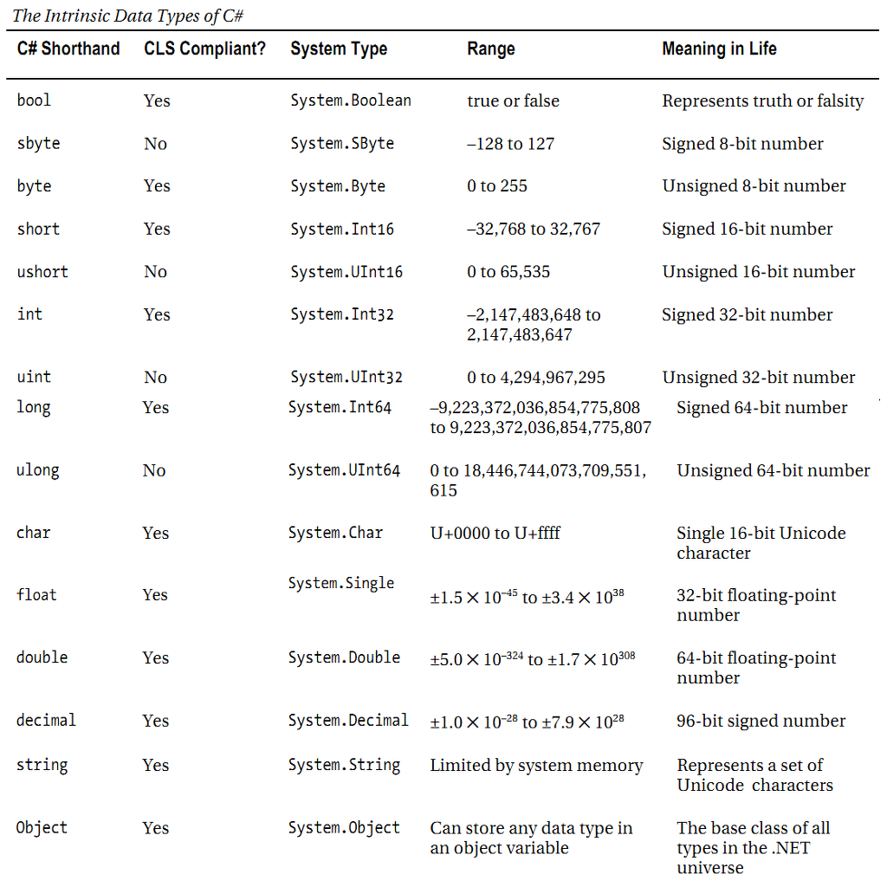

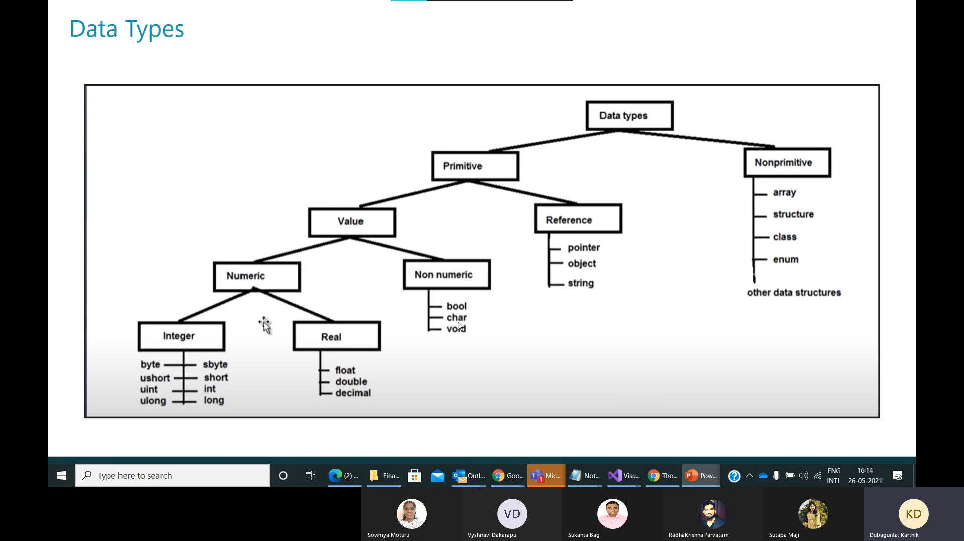

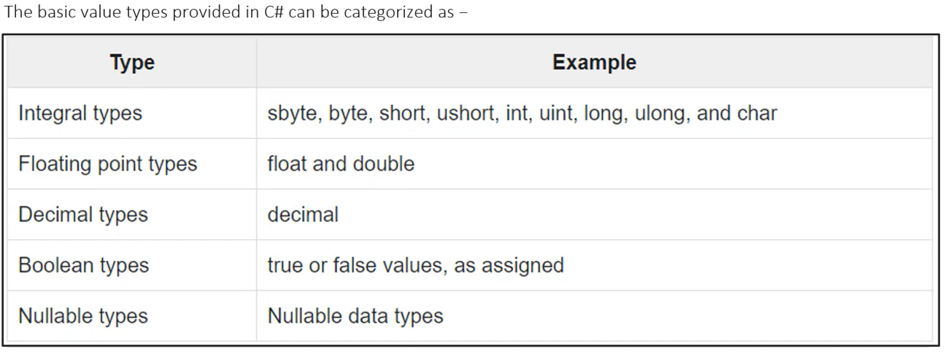

Types of Variables:

* 1. Local variables
  2. Instance variables
  3. Static variables (global variables)
  4. Constant variables ex: const double pi=3.14
  5. Read-Only variables [readonly keyword - C# Reference | Microsoft Learn](https://learn.microsoft.com/en-us/dotnet/csharp/language-reference/keywords/readonly)
* readonly indicates that assignment to the field can only occur as part of the declaration or in a constructor in the same class.
* A readonly field can be assigned and reassigned multiple times within the field declaration and constructor. Ex: readonly int n=0; (modifier)
* Because value types directly contain their data, a field that is a readonly value type is immutable.
* Because reference types contain a reference to their data, a field that is a readonly reference type must always refer to the same object. That object isn't immutable.
* For Reference type, the readonly modifier prevents the field from being replaced by a different instance of the reference type.

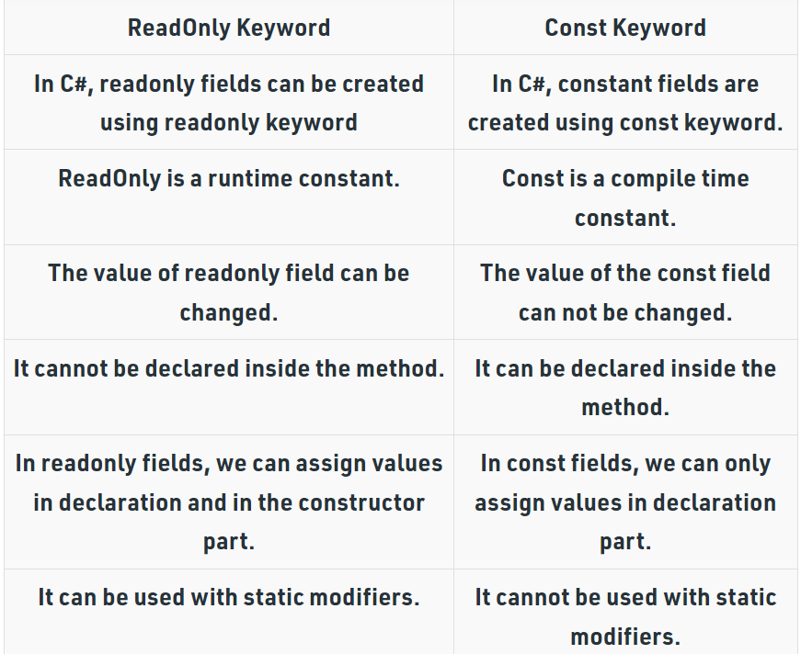

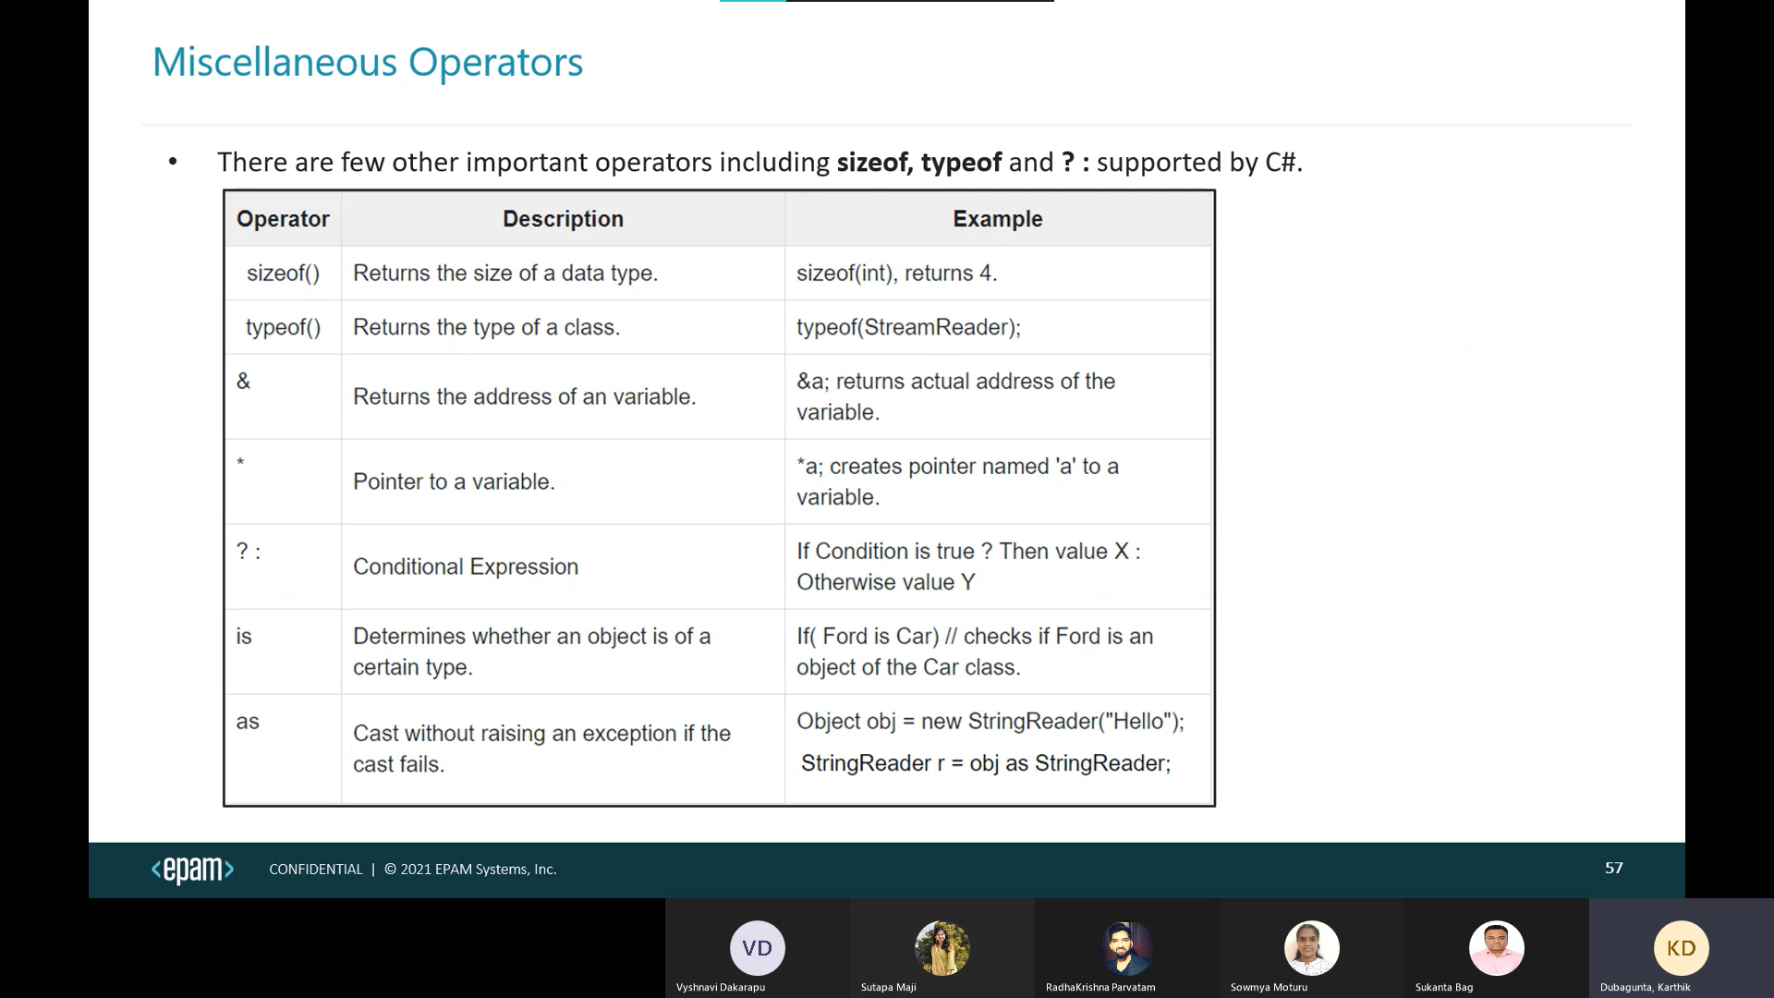

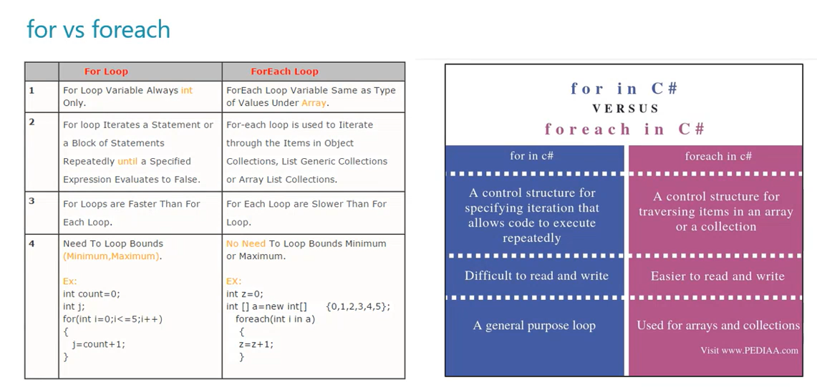

For can go backwards

Object class:

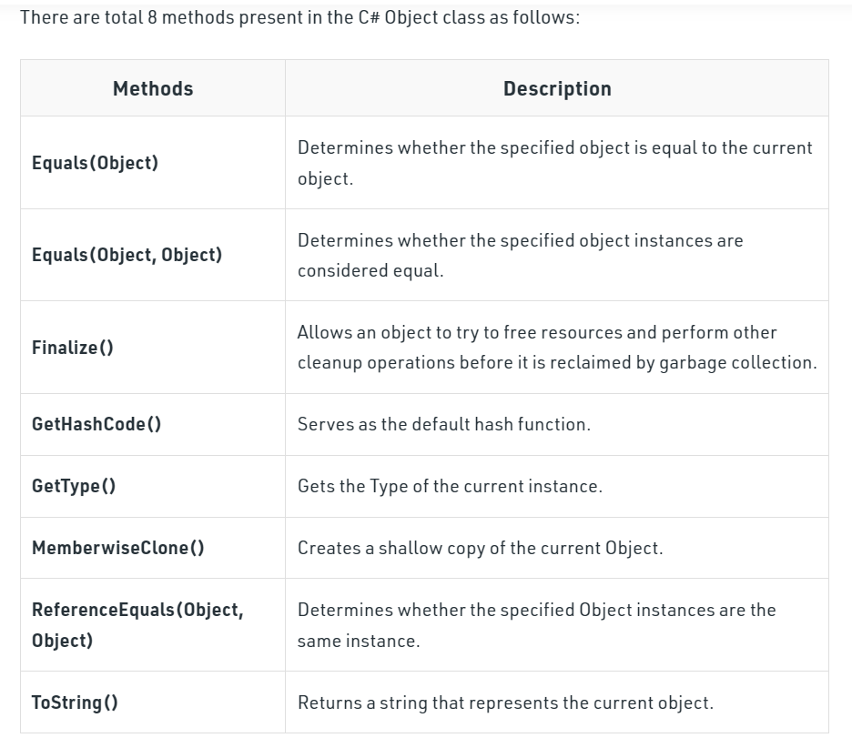

Access Specifiers:

[What are the default access modifiers in C#? - Stack Overflow](https://stackoverflow.com/questions/2521459/what-are-the-default-access-modifiers-in-c/3175697#3175697)

* By default, all members are private in C#
* We can’t declare private for Types.
* We can’t declare protected, protected internal, private for class. We can only use internal, public. By default, internal for class.

**Assembly (Project)**

1. Private 🡪 within class (default)
2. Public 🡪 everywhere
3. Protected 🡪 subclasses (same or different project)
4. Internal 🡪 within same Project
5. Protected internal 🡪 within same Project or derived types of another project.
6. Private Protected 🡪 within same class and derived classes of same project.

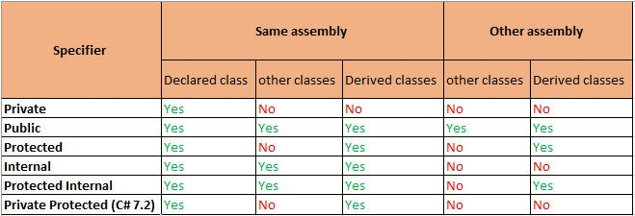

Namespaces:

* Namespaces in C# are used to organize too many classes so that it can be easy to handle the application. (We can import, organize, related classes, reuse the class, change class functionality)
* In C#, global namespace is the root namespace. The global:System will always refer to the namespace "System" of .Net Framework.
* To access the class of a namespace, we need to use namespacename.classname.
* We use using keyword to import that namespace.

Ex: we use System.Console where System is the namespace and Console is the class.

C# Properties can be read-only (only get) or write-only (only set).

 Structs are used for lightweight objects such as Color, Rectangle, Point etc.

Structs in C# are value type than reference type. It is useful if you have data that is not intended to be modified after creation of struct.

**Enum:**

* Enum is used to store a set of named constants such as season, days, month, size etc.
* Enum constants has default values which starts from 0 and incremented to one by one.
* Enum does not contain constructor and methods. To add functionality to an enumeration type, create an extension method.

1. (int)season ---- 4
2. Season----Winter
3. Enum.GetNames(typeOf(Season)), GetValues() sames as GetNames.

Iterators:

* This feature was introduced in ***C# 2.0***.
* An iterator can be used to step through collections such as lists and arrays.
* It uses the **yield return** statement to return the element from the collection at a time.
* it always remembers the current location of the iterator, so when the next iteration takes place, it will return the next element of the given collection.
* If you want to stop the iteration you will use the **yield break** statement.
* The return type of this method is IEnumerable, IEnumerable<T>, IEnumerator, or IEnumerator<T>. (GetEnumerator).
* You cannot use iterator in an events instance constructor, static constructor, or static finalizer.
* An iterator method does not contain in, ref, or [out](https://www.geeksforgeeks.org/out-parameter-with-examples-in-c-sharp/) parameters.
* Iterator can be used as a method, or as a property.
* Iterator method is also known as get accessor.

using System;

using System.Collections.Generic;

class GFG {

public static IEnumerable<string> GetMyList()

{

// Creating and adding elements in list

List<string> my_list = new List<string> () {

"Cat", "Goat", "Dog", "Cow”};

foreach (var items in my_list)

{

yield return items;

}

}

static public void Main ()

{

IEnumerable<string> my_slist = GetMyList();

foreach(var i in my_slist)

{

Console.WriteLine(i);

}

}

}

In IEnumerator First we need to MoveNext() and Current to get first element.

String, String Builder are present in c#

No StringBuffer, throws in dotnet.

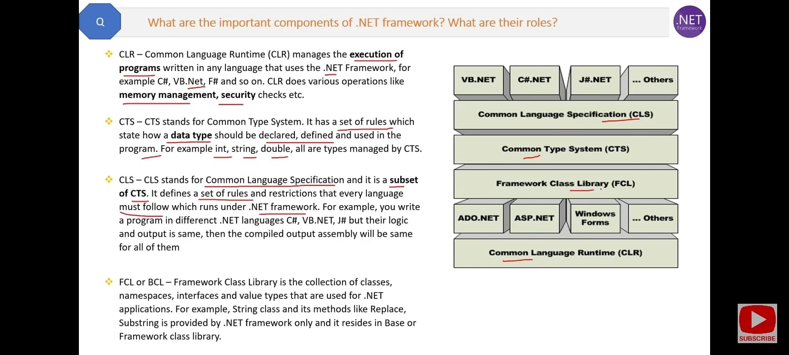

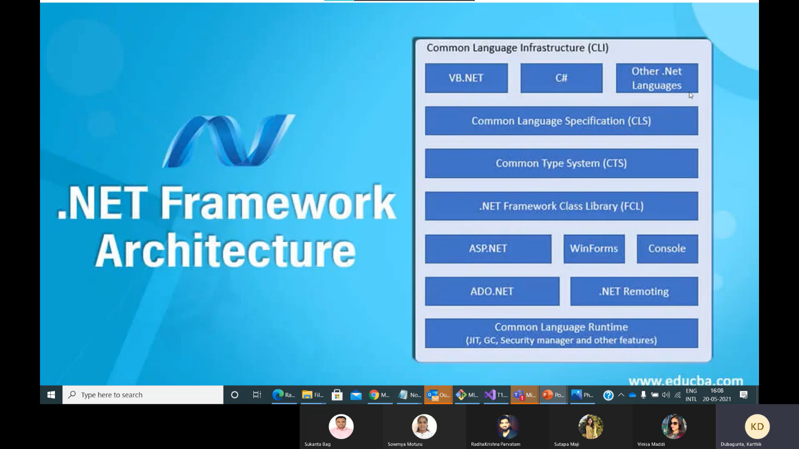

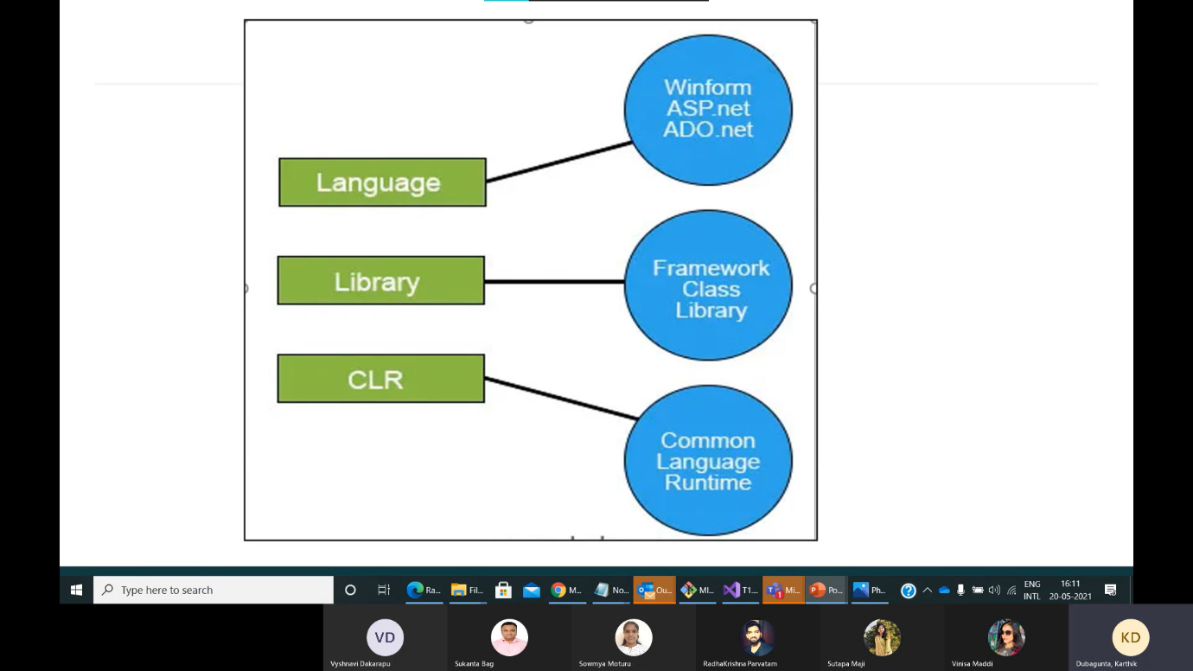 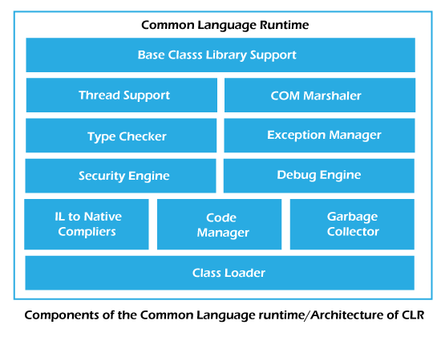

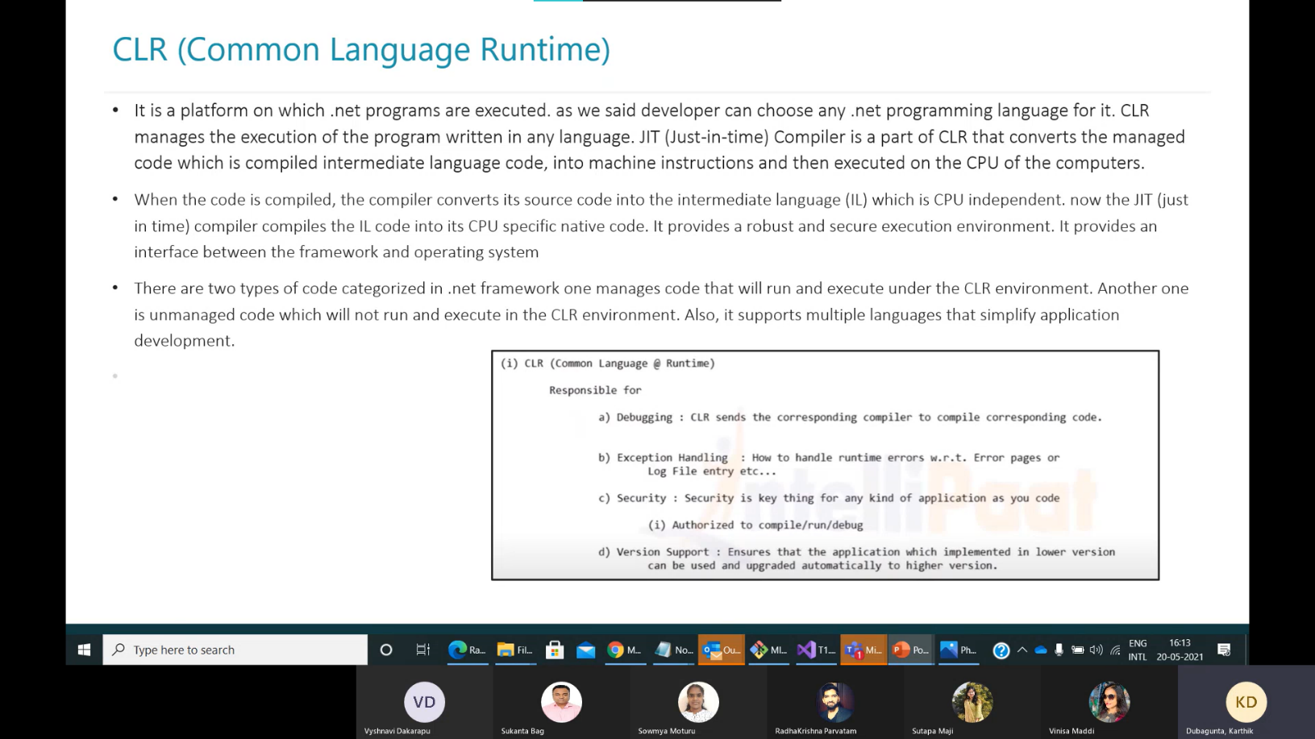

## **There are the following three types of JIT Compilers in Microsoft .Net Framework.**

**1)Pre-JIT**:

Pre-JIT Compiler compiles the whole source code into native code in a single cycle, done at the time of deployment of the application itself.

2) **Econo-JIT**:

Econo-JIT Compiler compiles only specific methods that are called at runtime. These compiled methods are removed once their processing is finished and not required in further execution.

3)**Normal-JIT**:

Normal-JIT Compiler compiles only specific methods that are called at runtime. These methods are compiled once and are stored in the cache. When the same methods are called again, the compiled code from cache will be used for execution.

dll 🡪 dynamic linked library

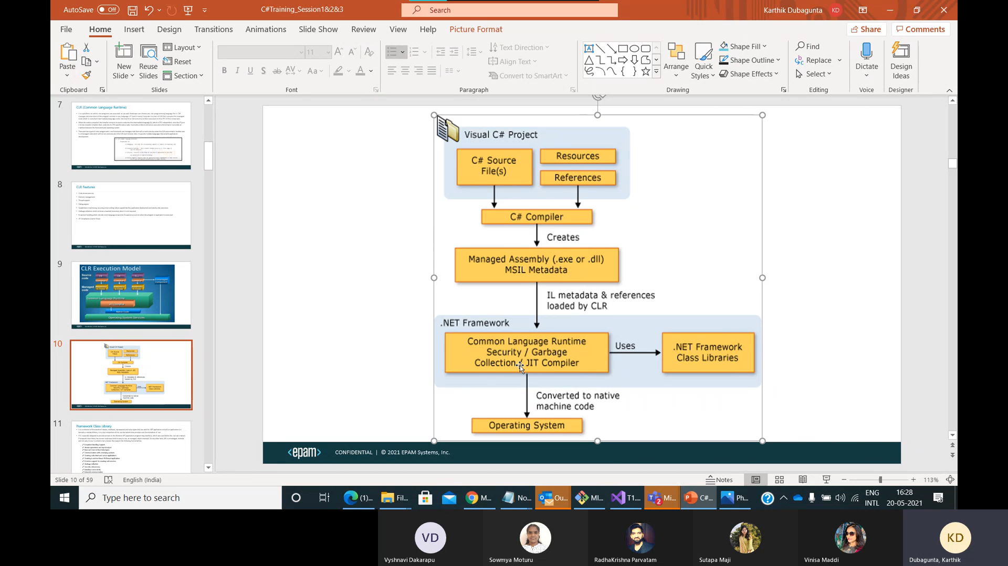

[C# Version History (tutorialsteacher.com)](https://www.tutorialsteacher.com/csharp/csharp-version-history)

The C# programming language was designed by [Anders Hejlsberg](https://en.wikipedia.org/wiki/Anders_Hejlsberg) from [Microsoft](https://en.wikipedia.org/wiki/Microsoft) in 2000 and was later approved as an [international standard](https://en.wikipedia.org/wiki/International_standard) by [Ecma](https://en.wikipedia.org/wiki/Ecma_International" \o "Ecma International) (ECMA-334) in 2002

C# 11 is latest version

First parent constructor is called and then child constructor is invoked.

Child object can access the variables and methods of parent class.

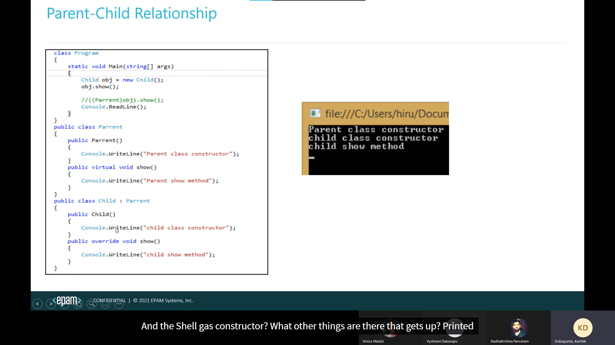

New modifier: (method hiding, shadowing)

When “new” used as a declaration modifier, the new keyword explicitly hides a member that is inherited from a base class.

When you hide an inherited member, the derived version of the member replaces the base class version.

The "new" keyword is used to hide a method, property, indexer, or event of the base class into the derived class.

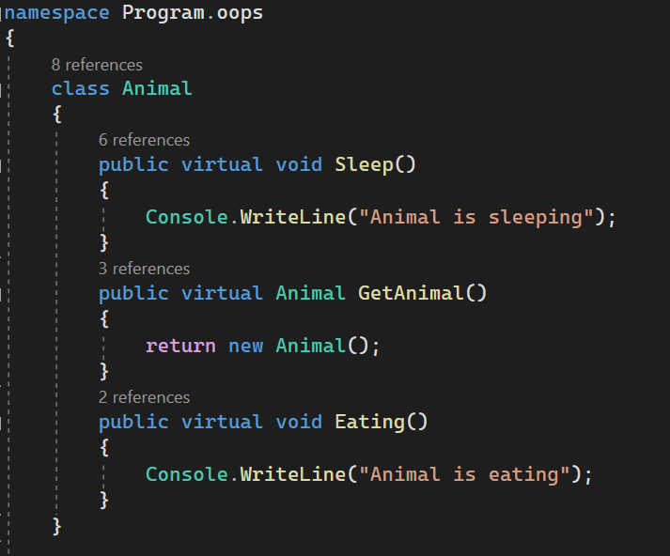 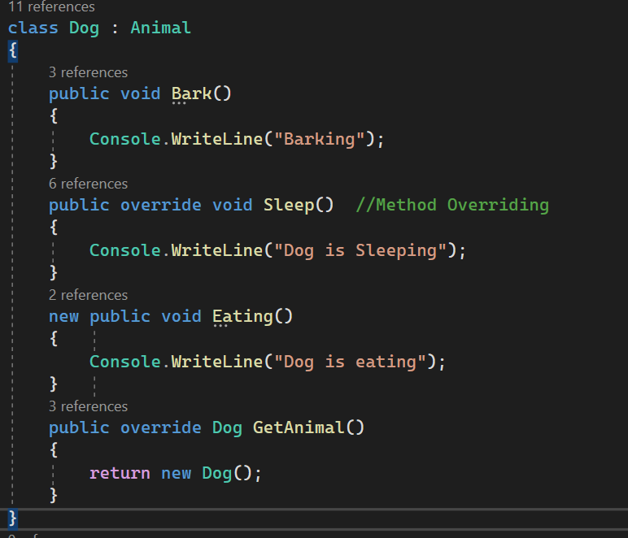

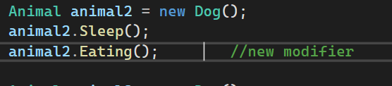

New is hiding eating method in derived class and it effects only in upcasting.

Output:  
Dog is sleeping Animal is eating

Array rank🡺 no of dimensions

Collections:

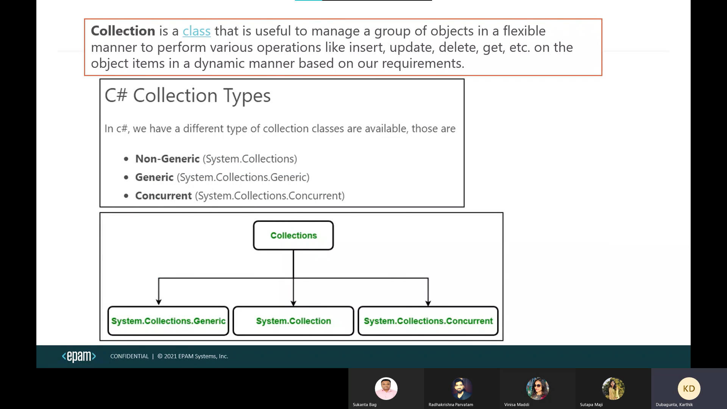

Non-Generic Collections:

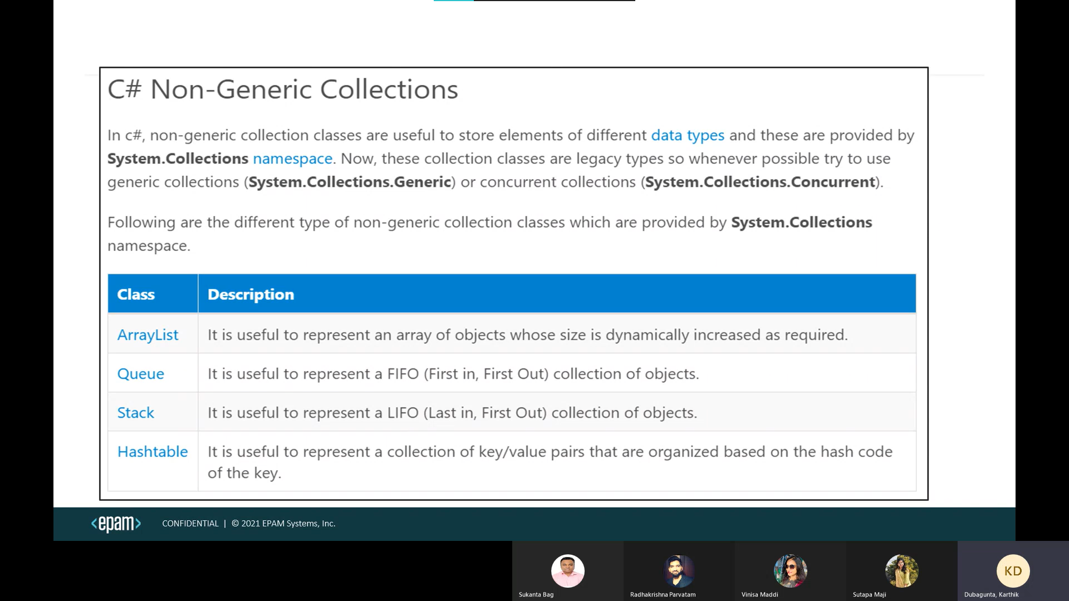

* The ArrayList, Queue, stack collection accepts null as a valid value. It also allows duplicate elements.
* Using multidimensional arrays as elements in an ArrayList collection is not supported.
* The**ArrayList could become jagged and could be considered not to be multidimensional any longer.**
* In Hashtable, the key cannot be null, but value can be. It uses hash code to store key and values. key objects must be immutable in the Hashtable.
* In Hashtable, key must be unique. Duplicate keys are not allowed.

ArrayList arrayList = new ArrayList();

arrayList.Add(1);

arrayList.Add(2);

arrayList.Add("pip");

arrayList.Add("io");

arrayList.Sort(); --- System.InvalidOperationException

ArrayList arr = new ArrayList(){“Zeh”, “zeh”};

arr.Sort() // output: zeh, zeh   
Here it will ignore cases, Lower case is prioritized first and follows ascii

Thread Safety: (public static)

* The collection classes in the System.Collections namespace include ArrayList and Hashtable. These classes provide some thread safety through the Synchronized property, which returns a thread-safe wrapper around the collection.
* System.Collections.Generic classes don't provide any thread synchronization
* Concurrent collections are thread safe.

Generic Collections:

* In Dictionary (no order), SortedList (sorted order) the key cannot be null, but value can be. key must be unique
* SortedList uses one array for the keys and another array for the associated values.
* List can accept null as a valid value for reference types and allows duplicate elements.
* Dictionary🡪hashing SortedList🡪list
* Hashset allows one null value and does not allow duplicates. (No order)
* The LinkedList<T> class does not support chaining, splitting, cycles, or other features that can leave the list in an inconsistent state.
* It allows null values and duplicates.
* The only multithreaded scenario supported by LinkedList<T> is multithreaded read operations.
* If the LinkedList<T> is empty, the First and Last properties contain null.

Generics

* SortedDictionary
* SortedSet

Class should implement IComparable interface because of “this” keyword list.Sort()

public int CompareTo(Object obj)

{

return this.Id.CompareTo(obj.Id);

}

New comparer class should be created to implement IComparer interface

public int Compare(Object obj1, Object obj2)

{

return obj1.Name.CompareTo(obj2.Name);

}

list.Sort(new Comparer class name())

Linked list is doubly linked list

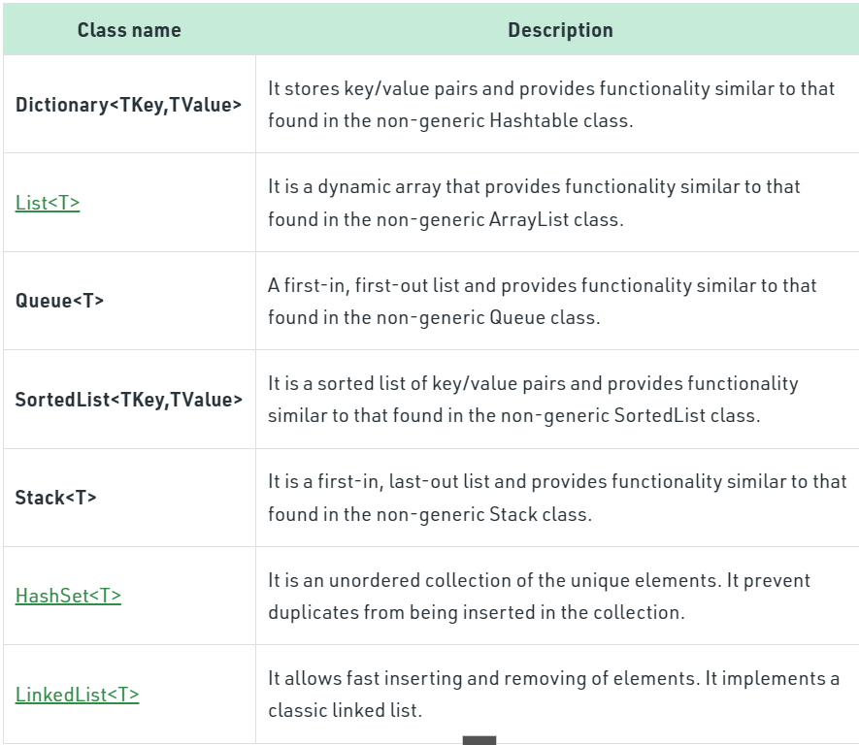

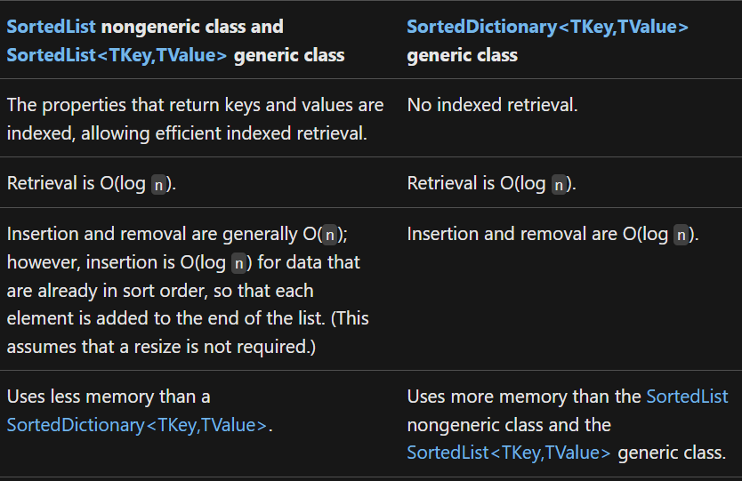

*sortedList uses List whereas sorted dictionaries binary search tree for sorting*

Concurrent Collections:

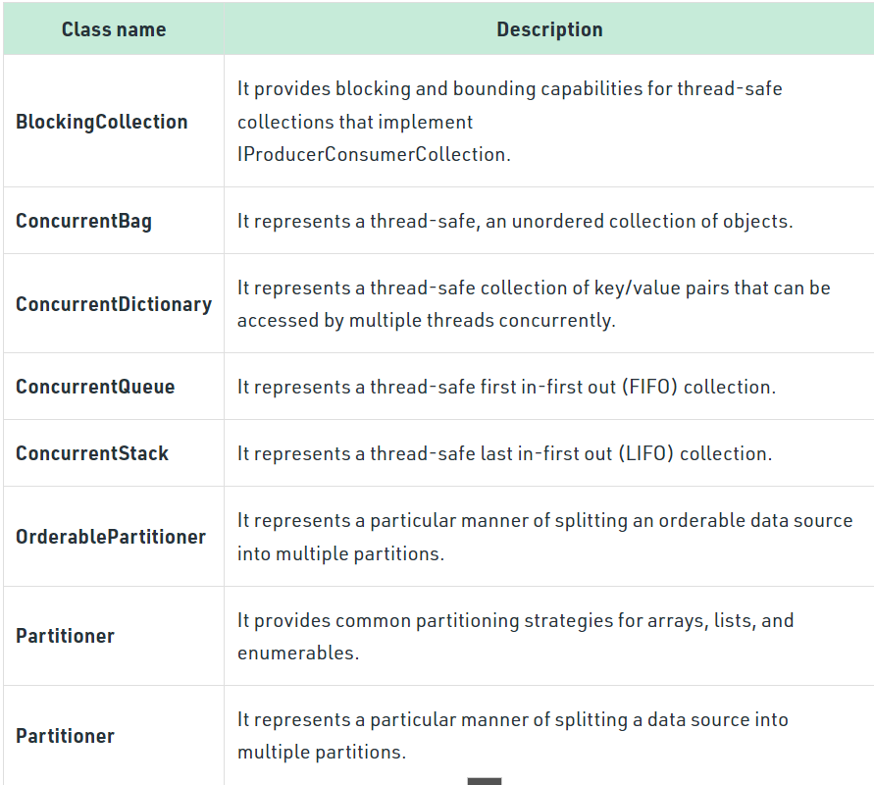

* clone - create something new based on something that exists.(always deep copy)
* copying - copy from something that exists to something else (that also already exists) (shallow or deep)

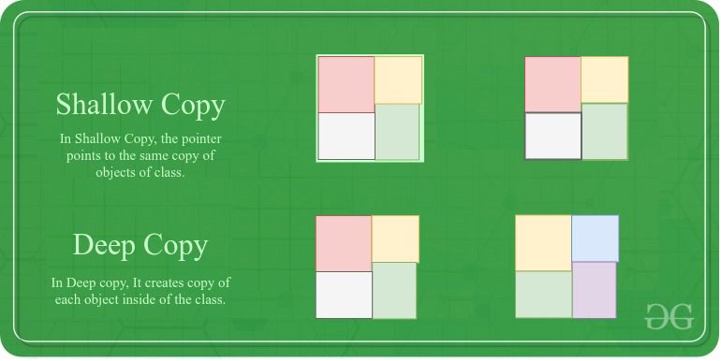 

Exception Handling:

Exceptions two types:

1. System Exceptions (Arthimetic Exception etc)
2. Application Exceptions (explicitly throwing our own Exceptions)

The checked keyword is used to explicitly check overflow and conversion of integral type values at compile time. And throws overflow Exception.

 whereas, in an unchecked context, arithmetic overflow is ignored, and result is truncated.

Some common Exceptions

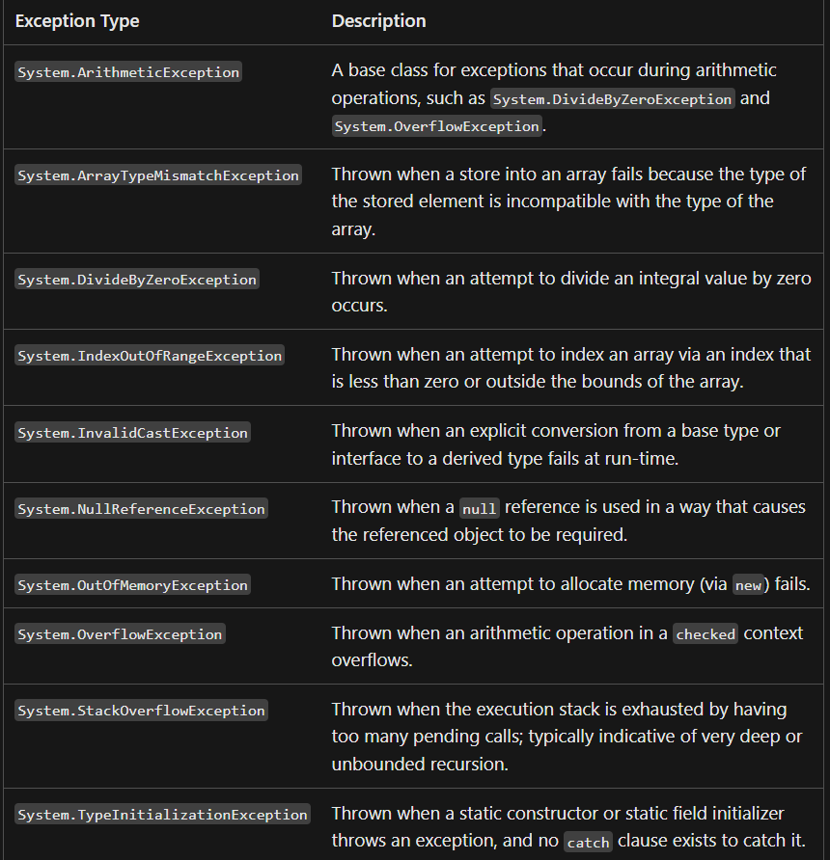

* try catch finally using throw
* using designed to give you an easy way to wrap a try/finally around an object that needs to be disposed. (Removing from the memory or closing)
* using can’t handle the Exceptions, we replace with try catch finally blocks to handle Exceptions.
* A variable declared by the using statement or declaration is readonly. You cannot reassign it or pass it as a ref or out parameter.
* When you declare several instances in one using statement, they are disposed in reverse order of declaration.

public class OddNumberException : Exception

{

public OddNumberException(string message) : base(message)

{

}

}

csc **helloworld.cs**  🡺 to compile your code.

**helloworld 🡺** to run the file

[Class Diagram in Visual Studio 2019 | Class Designer Getting Started - YouTube](https://www.youtube.com/watch?v=syYyQ7LlcPc)

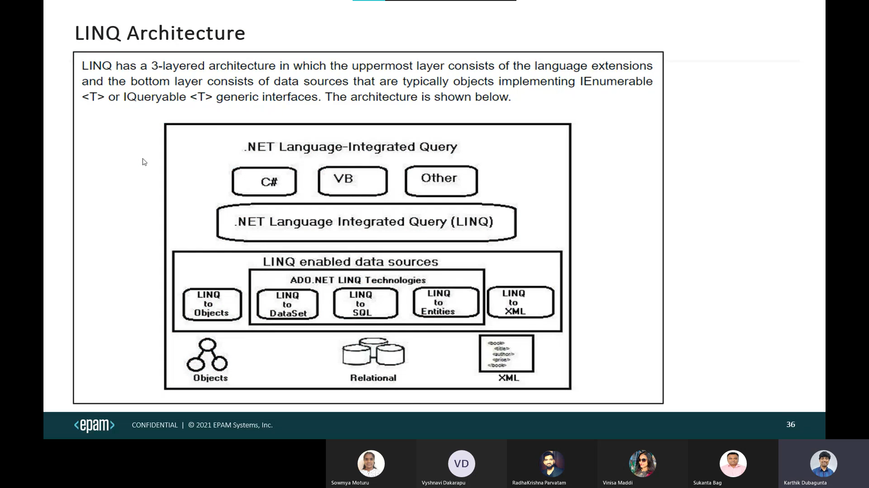

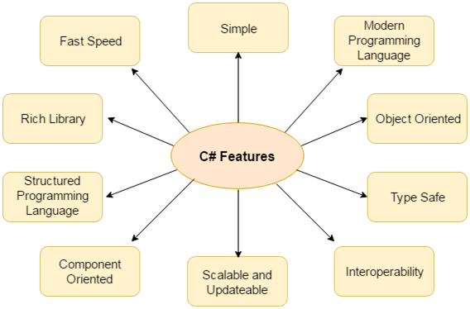

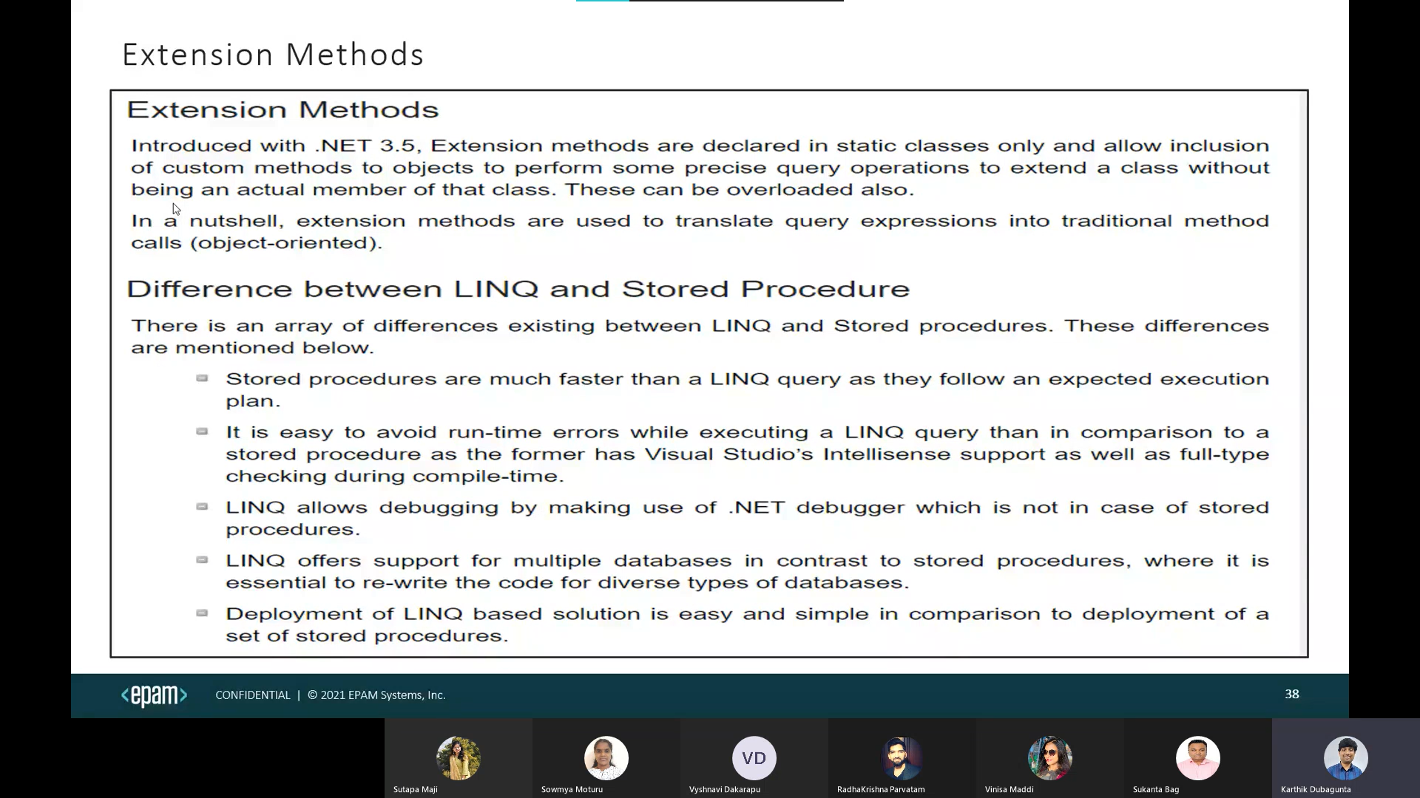

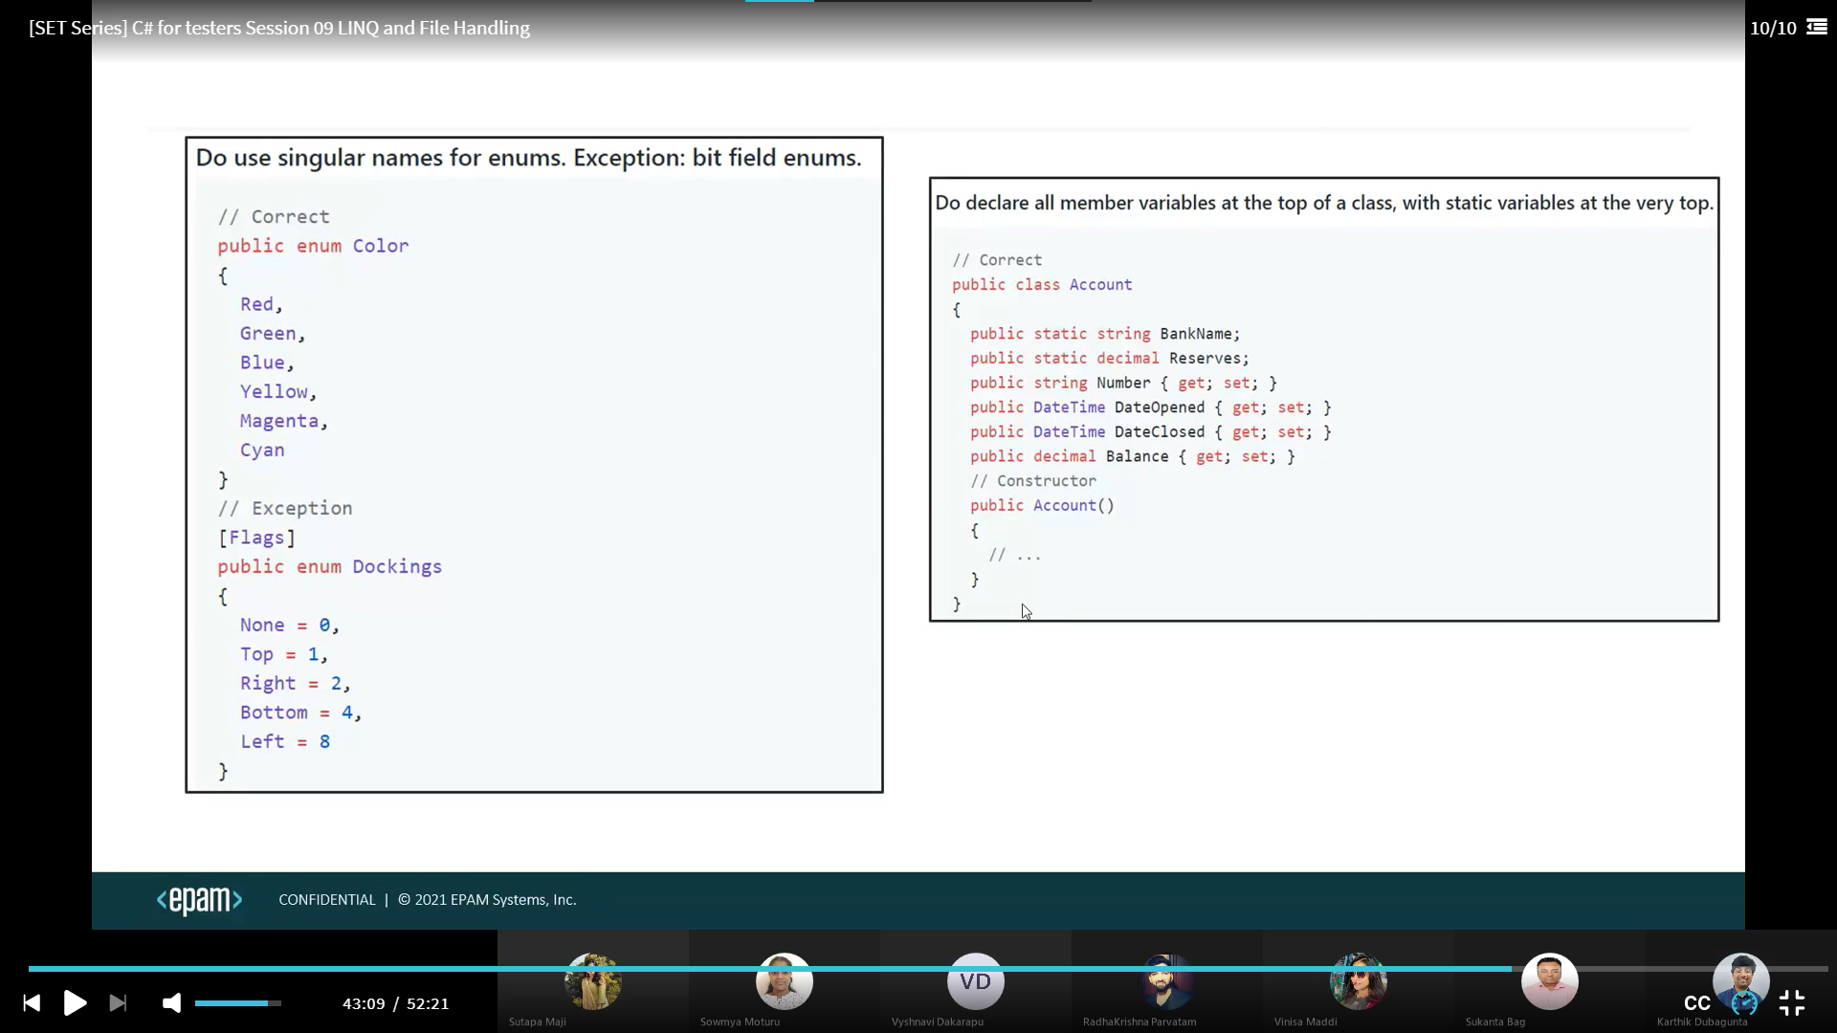

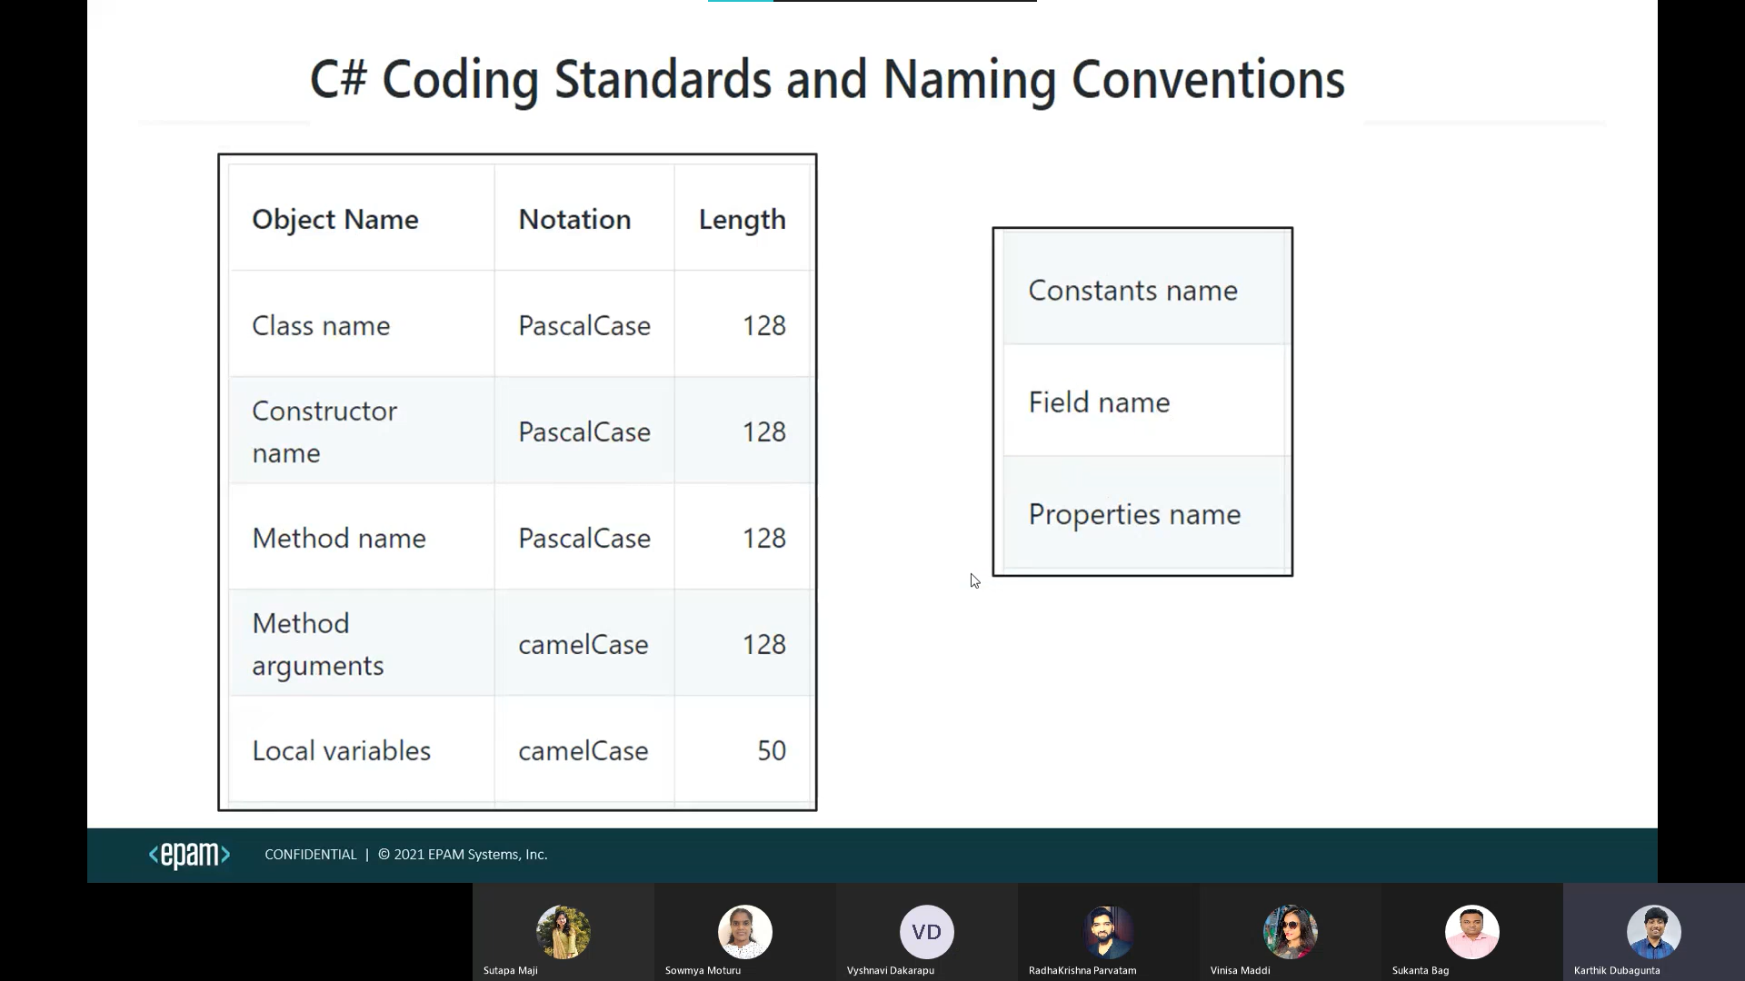

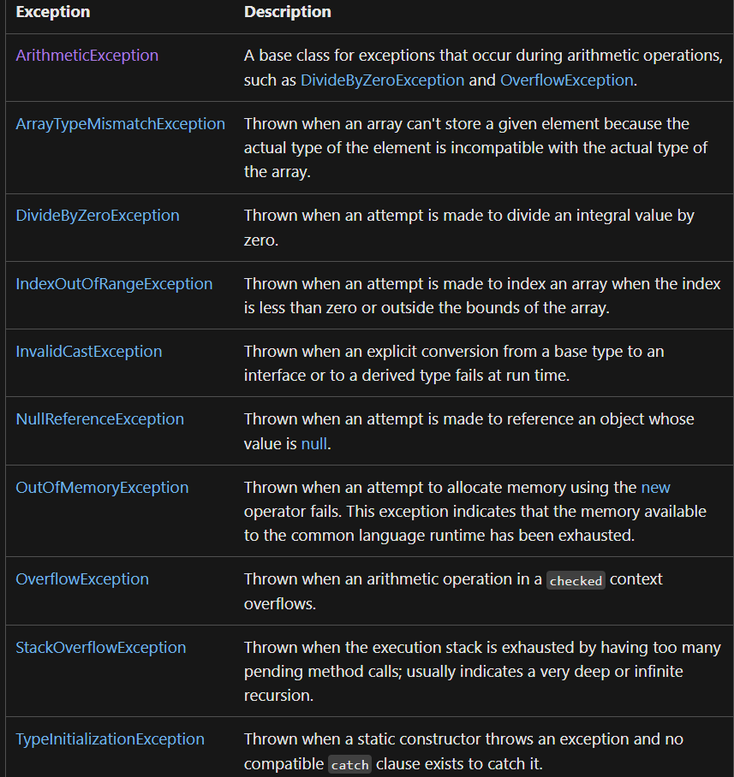

Indexers:

An indexer allows an instance of a class or struct to be indexed as an array. If the user will define an indexer for a class, then the class will behave like a virtual array.

**Syntax:**

[access_modifier] [return_type] this [argument_list]

{

get

{

// get block code

}

set

{

// set block code

}

}

**Important Points About Indexers:**

* There are two types of Indexers i.e. One Dimensional and Multi-Dimensional Indexers.
* Indexers can be overloaded.
* Indexers are also known as the *Smart Arrays* or *Parameterized Property* in C#.
* Indexer can’t be a static member as it is an instance member of the class.

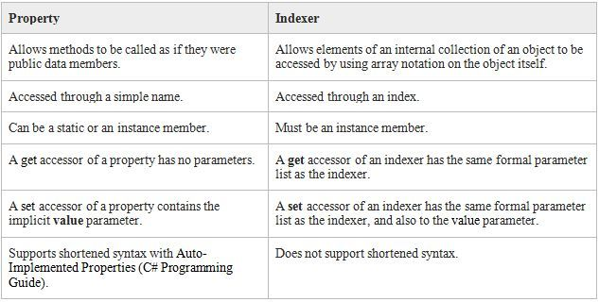

Supports expression bodied members for get only indexers.

|  |  |
| --- | --- |
| Indexers are created using this keyword | Properties don't require this keyword |
| Indexers can be overloaded | Properties can't be overloaded |
| Indexers are identified by signatures | Properties are identified by their names. |

Properties are first class citizens in C#.

A field defines a storage location

However, unlike fields, properties are implemented with accessors that define the statements executed when a property is accessed or assigned.

Properties are helpful in validation in setter ,Encapsulation and synchronization than fields.

Tuples:

* System.ValueTuple types are value types. System.Tuple types are reference types.
* System.ValueTuple types are mutable. System.Tuple types are immutable.
* Data members of System.ValueTuple types are fields. Data members of System.Tuple types are properties

(int a, byte b) left = (5, 10);

(long a, int b) right = (5, 10);

Console.WriteLine(left == right); // output: True

Console.WriteLine(left != right); // output: False

var t1 = (A: 5, B: 10); //independent of field names

var t2 = (B: 5, A: 10);

Console.WriteLine(t1 == t2); // output: True

Console.WriteLine(t1 != t2); // output: False

* multiple return types
* combination of collections
* hold database record temporarily.
* It is of reference type not of value type.
* It is limited to eight elements. Means you cannot store more than eight elements without nested tuple.
* These are only accessed by using *Item<elementNumber> property*

Linq:

[LINQ Tutorial - Javatpoint](https://www.javatpoint.com/linq)

Generics type Constraints:

Constraints inform the compiler about the capabilities a type argument must have.

Without any constraints, the type of argument could be any type. The compiler can only assume the members of System.Object.

New()🡪The type argument must have a public parameterless constructor.

[Constraints on type parameters - C# Programming Guide | Microsoft Learn](https://learn.microsoft.com/en-us/dotnet/csharp/programming-guide/generics/constraints-on-type-parameters)

[new constraint - C# Reference | Microsoft Learn](https://learn.microsoft.com/en-us/dotnet/csharp/language-reference/keywords/new-constraint)

**BinaryFormatter.Deserialize(stream)**

**BinaryFormatter.Serialize(stream, reference)**

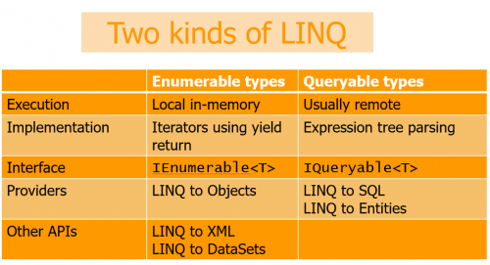

Iquerable is the child Of IEnumerable

Iquerable contains ElementType, Expression, (query)Provider without setters in system.Linq

IEnumerable contains GetEnumerator() method in System.Collections namespace.

IEnumerator Contains current with get, MoveNext(), Reset() methods System.Collections namespac

Range:  used to generate the sequence of integers upto count.

TakeWhile: will take values until condition fails, once failed it no longer takes values

SkipWhile: will skip values until condition fails, once failed it no longer skip values

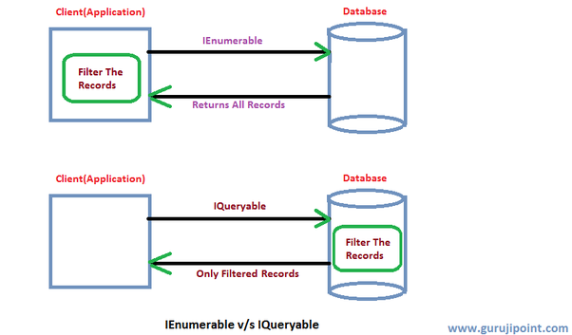

ICloneable contains clone() method.

IDisposable contains dispose() method which frees,release,reset unmanaged code

IEqualityComparer<T> contains Equals() and GetHashCode() methods in system.Collections.Generic namespace.

IEquatable<T> contains Equals() method in system namespace.

IComparable<T> contains CompareTo(obj) method in System namespace.

IComparer <T> contains Compare(obj1,obj2) method in System.Collections.Generics namespace.

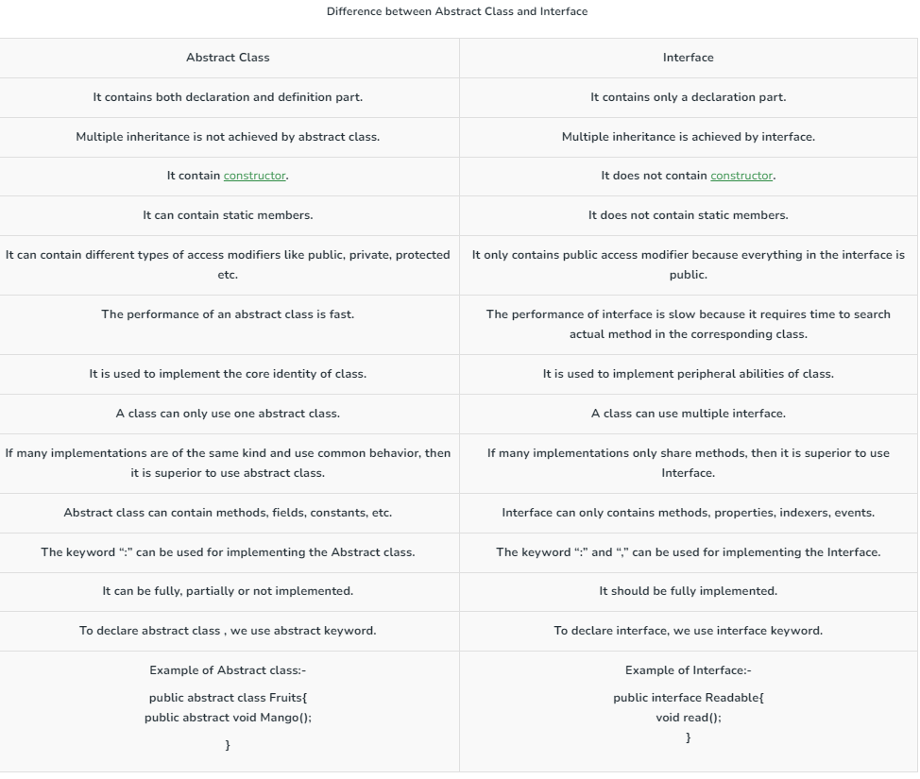

array accepts null value only when it is string type otherwise it does not accepts null value.

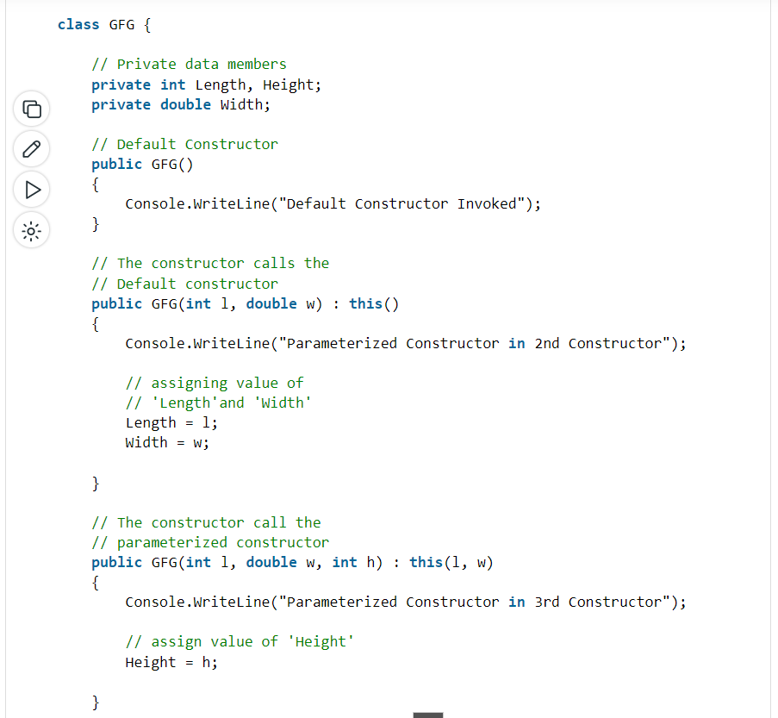

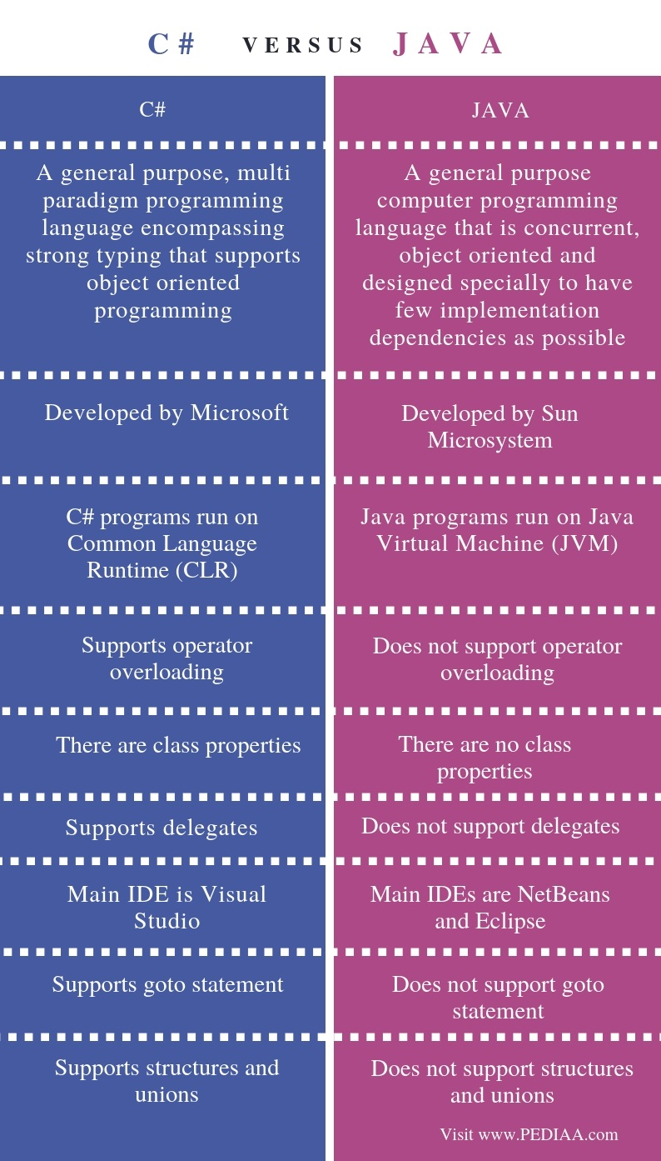 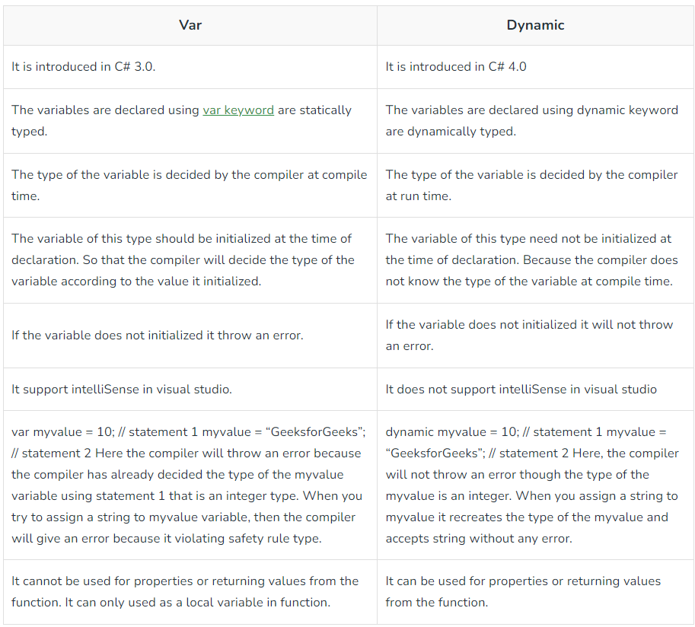

[Nested ClassesSin C# - GeeksforGeeks](https://www.geeksforgeeks.org/nested-classes-in-c-sharp/)

[What is Anonymous Types in C#? - GeeksforGeeks](https://www.geeksforgeeks.org/c-sharp-anonymous-types/)

**These are the methods of system.console**

* [Read**Key**()](https://msdn.microsoft.com/en-us/library/471w8d85(v=vs.110).aspx) (returns a **character or** ConsoleKeyInfo): reads only one single character from the standard input stream or command line. Usually used when you're giving options to the user in the console to select from, such as select A, B or C. Another prominent example, Press Y or n to continue.
* [Read**Line**()](https://msdn.microsoft.com/en-us/library/system.console.readline(v=vs.110).aspx) (returns a **string**): or Console.Readline() reads a single line from the standard input stream or the command line. As an example, it can be used to ask the user enter their name or age. It reads all the character till we press **enter**.
* [Read()](https://msdn.microsoft.com/en-us/library/system.console.read(v=vs.110).aspx) (reads and returns an **int**): or Console.Read() reads only one single character from the standard input stream. Similar to ReadKey except that it returns an integer. It returns the next character from the input stream, or returns (-1) if there is no more character to be read.
* Char is converted to int(Ascii)

(There are more system.console methods like write() and writeline() as well which are used to write in command line, behaving similarly as read() and readline() methods)

Object pooling offers the following pros for C# programmers:

* Object pooling can help improve performance by reusing objects that have already been instantiated, instead of creating new ones.
* It can also help reduce memory usage, since objects that are no longer needed can be returned to the pool rather than being left to be garbage collected by the runtime.
* Additionally, object pooling can make code more readable and maintainable by keeping track of objects in a central location.

Object pooling also has the following cons in C# software development: (design Pattern)

* One potential downside of object pooling is that it can introduce complexity to your code.
* Additionally, if not used correctly, object pooling can lead to decreased performance or memory leaks.

Delegate are declared inside class or outside class , inside or outside namespace.

Delegates types are sealed.

Generics in C# types are defined during runtime where in java they are type erasures they are defined in compiletime.

Log4Net:

<https://youtu.be/0Z8ai7K-_1g>

Nunit:

* MaxTime(n)
* This attribute does not cancel the test if the time is exceeded. It merely waits for the test to complete and then compares the elapsed time to the specified maximum. If you want to cancel long-running tests.
* The **Timeout Attribute** is used to specify a timeout value in milliseconds for a test case. If the test case runs longer than the time specified it is immediately cancelled and reported as a failure, with a message indicating that the timeout was exceeded.
* Collections of datapoints may be provided by use of the **DatapointSourceAttribute.** The **DatapointSource** attribute is used to provide data for **Theories.**

# LevelOfParallelism: the maximum number of worker threads executing tests in the assembly.

* Ordered tests are started in ascending order of the order argument .

Values by default -Combinatorial approach

Combinatorial, pairwise, sequential.

[TestCaseSource(typeof(AnotherClassWithTestFixtures),nameof(AnotherClassWithTestFixtures.DivideCases))]

Typeof only for IEnumerator (yield return).

<https://learn.microsoft.com/en-us/dotnet/core/testing/selective-unit-tests?pivots=mstest>

dotnet test --filter TestCategory=Positive

[OneTimeSetUp] works as you expect. It executes once, before all your tests and all your tests will use the same product.

[Setup] operations are performed just before each test method is called.

Assert.Multiple(() => {

Assert.That(result.RealPart, Is.EqualTo(5.2)); Assert.That(result.ImaginaryPart, Is.EqualTo(3.9));

});

For Debugging in Visual Studio:

* ctrl+click or F12
* Retry--> first time not execute because of delay, api testing.
* .net core in visual studio.
* select var right click debug and change value while debugging
* quick watch in debug

Jenkins:

[CI with Jenkins training | EPAM Video Portal](https://videoportal.epam.com/video/8JYK0zod)

We can traverse both forward and backward in DOM, i.e we can move from parent to child element and also from child to the parent element with xpath. However for css, we can only traverse from parent to child and not vice-versa.

Selenium:

It uses the process of serialization (convert Object’s data to JSON Format) and de-serialization(convert JSON format to object) just like REST web services.

**IME (Input Method Engine)**

[What is Selenium WebDriver Architecture? How Does it works? (toolsqa.com)](https://www.toolsqa.com/selenium-webdriver/selenium-webdriver-architecture/)

[Selenium Webdriver - Exceptions (tutorialspoint.com)](https://www.tutorialspoint.com/selenium_webdriver/selenium_webdriver_exceptions.htm)

Window Handles:

[Selenium C# Tutorial: Handling Multiple Browser Windows (lambdatest.com)](https://www.lambdatest.com/blog/selenium-c-tutorial-handling-multiple-browser-windows/#:~:text=Commands%20Used%20For%20Window%20Handling%20In%20Selenium%20C%23,open%20instances%20of%20the%20browser%20under%20test.%20)

Once the[Selenium WebDriver](https://www.lambdatest.com/blog/selenium-webdriver-tutorial-with-examples/) instance is instantiated, a unique alphanumeric id is assigned to the window. This is called window handle and is used to identify browser windows. Since the id is unique, it is used by the Selenium WebDriver to switch between different windows (or tabs).

Close ()🡺 close only current instance of the driver.

Quit ()🡺 Closes all instances of the driver.

Cases to use Quit ():

1. Multiple tabs are open.
2. Error occurred like driver already in use.

WebDriver Commands:

1. Url
2. Title
3. PageSource
4. CurrentWindowHandle
5. WindowHandles
6. Close, Quit, dispose.
7. FindElement, FindElements
8. Manage
9. SwitchTo
10. Navigate

Web Element Commands:

1. TagName
2. Text
3. Enabled
4. Selected
5. Location
6. Size
7. Displayed
8. Clear
9. SendKeys
10. Submit
11. Click
12. string GetAttribute(string attributeName);
13. string GetDomAttribute(string attributeName);
14. string GetDomProperty(string propertyName);
15. string GetCssValue(string propertyName);
16. ISearchContext GetShadowRoot();

Most people don't know the difference between an element attribute and an element property, so the traditional getAttribute method returns either the attribute or the property depending on which the you probably want. It does a good job of this. When moving to a w3c standard, though, we can't define a "best guess at what user wants" endpoint, so there is an attribute endpoint and a property endpoint. For backwards compatibility, we kept the original behavior for getAttribute and it is now implemented by sending a large chunk of JavaScript to the browser. The new methods are named slightly differently in different languages, but essentially getDomAttribute & getDomProperty which always return the exact value for property and attribute.

GetShadowRoot()🡺ShadowDOM is used to separate certain HTML structure, JS and CSS from the actual application DOM.

Encapsulated one

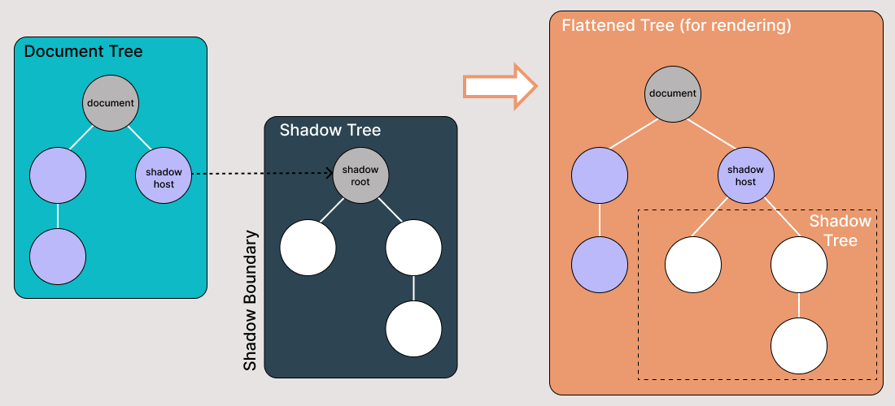

Navigation Commands:

1. GoToUrl()
2. Back()
3. Forward()
4. Refresh()
5. Equals(), GetType(), ToString().

IReadOnlyCollection: It Contains only count property with get. (thread safe) multiple readers are allowed.

Using System.Collections.Generic.

ReadOnlyCollection:

Using System.Collections.ObjectModel;

The fact that ReadOnlyCollection is immutable means that the collection cannot be modified, i.e. no objects can be added or removed from the collection. This does not mean that the objects it contains immutable.

Count, list[i], contains(), CopyTo(), GetEnumerator(), IndexOf().

Add, Insert, Remove, RemoveAt, Clear 🡺 Throws NotSupportedException.

Implements IList, IList<T>, IReadOnlyList<T>

**GetCssValue() vs GetAttribute():**

* Inside style attribute properties are printed through GetCssValue()

<input type = "text" id = "firstName">

* getAttribute("type") = "text"
* getCssValue("type") = ""

Implicit Waits:

1. Implicit Wait
2. PageLoad
3. Asynchronous JavaScript
4. Thread.Sleep()

***Default value of implicit wait is 0 seconds***. Implicit wait has a default polling time of 250 milliseconds.

**Explicit Waits:** They are Smart waits which waits for the time till the condition specified *in wait* ***.until*** *(* YourCondition*) method becomes*true. Polling Time=500ms

Fluent Waits:

The ***polling time (or polling interval)*** is the time interval in which Selenium starts searching again after the last failed try. Again Repeats the Steps.

Custom Waits:

Webdriver Wait: It is bounded to webDriver

Default Wait: Default wait is more generic wait in the sense that it is not bound to WebDriver. This wait can be used to pass in any object to wait on.

SwitchTo()🡺 Handling Windows, Alerts, Frames.

ActiveElement, ParentFrame, DefaultContent, Frame, Window

**ActiveElement** - Switches focus to element that has focus at the moment. If there’s no element with focus, this method will switch to body element of the page.

**Alert** - Switches focus to currently active dialog box.

**DefaultContent** - Switches focus to the first frame on the page or main document if page contains iframes.

**Frame** - Switches focus to frame by given index.

**ParentFrame** - Switches focus to parent frame of currently selected frame.

**Window** - Switches focus to the window with specified name.

1. webDriver.Close() - Close the browser window that the driver has focus of
2. webDriver.Quit() - Calls Dispose()
3. webDriver.Dispose() - Closes all browser windows and safely ends the session.

Best Practices of Locating Elements in Selenium:

* Choose the right Selenium locator to recognize a web element in Selenium.
* Avoid using dynamic attribute values to locate different elements in the Selenium locator.
* Use ID and name attributes when your web page contains a unique set instead of XPath for a speedy process.
* When using locators, ensure that the locator points directly to the needed element.
* Avoid anything that causes breakage in the script, such as using auto-generated elements since we generate element attribute properties at a run time in a dynamic web environment.
* When using CSS or XPath locators, avoid using those generated by the Chrome Dev Tools. This leads to code breakage, maintenance, and reliability issues.
* Always keep your locators short of identifying them easily.

Alerts:

1. Simple Alerts
2. Confirmation Alerts
3. Prompt Alerts.

Actions:

KeyDown:

The keyDown() method is used for pressing and holding a key. The keys that we are referencing here are the Shift, Ctrl, and Alt keys.

The keyUp() method is used to release the key that is already pressed using the keyDown() method.

JavaScriptExecutor is used when Selenium Webdriver fails to click on any element due to some issue.

* JavaScriptExecutor provides two methods “executescript” & “executeAsyncScript” to handle.
* Executed the JavaScript using Selenium Web driver.
* Illustrated how to click on an element through JavaScriptExecutor, if selenium fails to click on element due to some issue.
* Generated the ‘Alert’ window using JavaScriptExecutor.
* Navigated to the different page using JavaScriptExecutor.
* Scrolled down the window using JavaScriptExecutor.
* Fetched URL, title, and domain name using JavaScriptExecutor.
* <https://blog.qasource.com/software-development-and-qa-tips/how-to-resolve-element-click-intercepted-exception-in-selenium>

Relative Locators:

* **Below():** Web element located below for the specified element.
* **LeftOf() :** Target web element which is present to the left of specified element.
* **RightOf():** Target web element which is presented to the right of a specified element.
* **Above():** Web element located above for the specified element.
* **Near() :** Target web element which is away(approx. 50 pixels) from the specified element.

**StaleElementReferenceException:** This Selenium exception occurs happens when the web element is detached from the current DOM.

Selenium Grid:

* The ***Selenium Grid*** is a testing tool which allows us to run our tests on different machines against different browsers. It executes tests Parallelly.
* The new Selenium Grid comes with Docker support and we can deploy on Kubernetes.

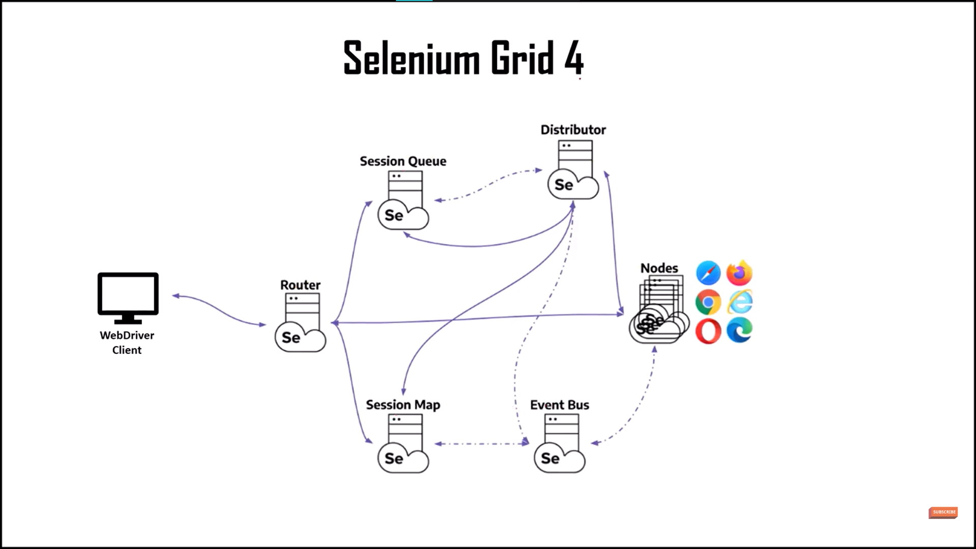

driver=new RemoteWebDriver (new Uri(http://localhost:4444),options);

C:\Users\Vishnu_Kolluri\Selenium_Grid

Selenium Grid Components:

1. **Router** = It is the Entry point of Selenium Grid. From WebDriver client it takes requests and pass to session or node. If we have request in existing session, it will directly pass request to node.
2. **Session map** = It is used for data storage, it contains information of sessionId, NodeId.
3. **Session Queue** = (FIFO) store session request
   1. Request timeout
   2. Session Retry
4. **Distributor** = It sees session Queue if there are any pending requests and pass to node and it registers the node.
   * 1. It creates requested session at the node.
     2. and keeps the information of node and capabilities in the Selenium Map.
5. **Event bus** = node sends registration event to the Event bus.
   * 1. Internal Communicator in the grid
     2. distributor reads the Event bus to check node is reachable otherwise it throws node unreachable Exception.
6. **Node** = server or machines, where multiple instances or browsers are running, and our test scripts are executed.

Selenium Grid Modes:

1. **Standalone Mode:**  (5 or less node)

* + java -jar selenium-server-4.8.0 standalone

2. **Hub and Node Mode**: (6 to 100 nodes)

Same Machine:

* + java -jar selenium-server-4.9.0.jar hub
  + java -jar selenium-server-4.8.0.jar node --port 7777

Different Machine:

* + java -jar selenium-server-4.8.0 node --hub http://localhost:4444

3. **Distributed Mode:** (more than 100 nodes)

* In this mode each component should be registered at different VMs

<https://youtu.be/J6EdJ6wBZPQ>

[FindsBy(How=How.Id, Using = "g2599-name")]

[CacheLookup]

PageFactory.InitElements(driver, obj);

**Specflow: (Tricentis)**

**reqnroll**

## Step Definition Methods Rules

* Must be in a public class, marked with the [Binding] attribute.
* Must be a public method.
* Can be either a static or an instance method. If it is an instance method, the containing class will be instantiated once for every scenario.
* Cannot have out or ref parameters.
* Should return void or Task.
* SpecFlow supports a very simple dependency framework that is able to instantiate and inject class instances

[Create calculator project — documentation (specflow.org)](https://docs.specflow.org/projects/getting-started/en/latest/GettingStarted/Step2.html)

[Gherkin Reference — documentation (specflow.org)](https://docs.specflow.org/projects/specflow/en/latest/Gherkin/Gherkin-Reference.html) 26.2.0

[Step Definitions — documentation (specflow.org)](https://docs.specflow.org/projects/specflow/en/latest/Bindings/Step-Definitions.html)

[Sharing Data between Bindings — documentation (specflow.org)](https://docs.specflow.org/projects/specflow/en/latest/Bindings/Sharing-Data-between-Bindings.html)

[Hooks — documentation (specflow.org)](https://docs.specflow.org/projects/specflow/en/latest/Bindings/Hooks.html)

[Scoped Step Definitions — documentation (specflow.org)](https://docs.specflow.org/projects/specflow/en/latest/Bindings/Scoped-Step-Definitions.html)

[Command Line Usage — SpecFlow+ Runner documentation](https://docs.specflow.org/projects/specflow-runner/en/latest/Usage/SpecFlowPlus-Runner-Command-Line.html)

* A Background allows you to add some context to the scenarios that follow it. It can contain one or more Given steps, which are run before *each* scenario, but after any [Before hooks](https://docs.specflow.org/projects/specflow/en/latest/Bindings/Hooks.html).
* A Scenario Outline must contain an Examples
* The automation that connects the Gherkin specifications to source code is called a *binding*.
* By default the hooks of the same type (e.g. two [BeforeScenario] hook) are executed in an unpredictable order.
* When running tests in multiple threads with SpecFlow+ Runner, Before and After hooks such as BeforeTestRun and AfterTestRun are executed once for each thread.

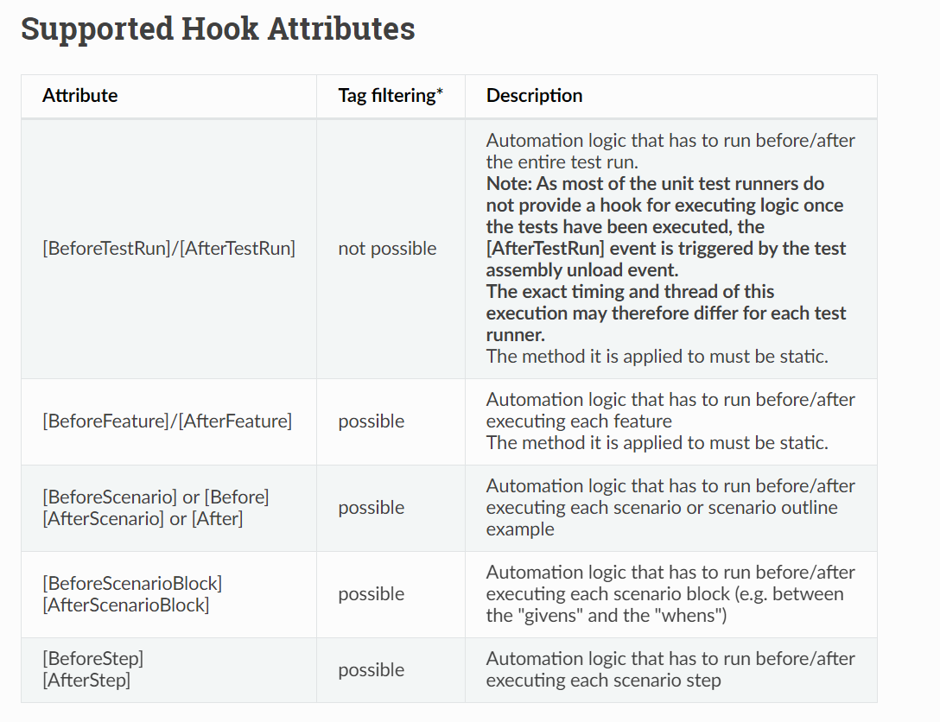

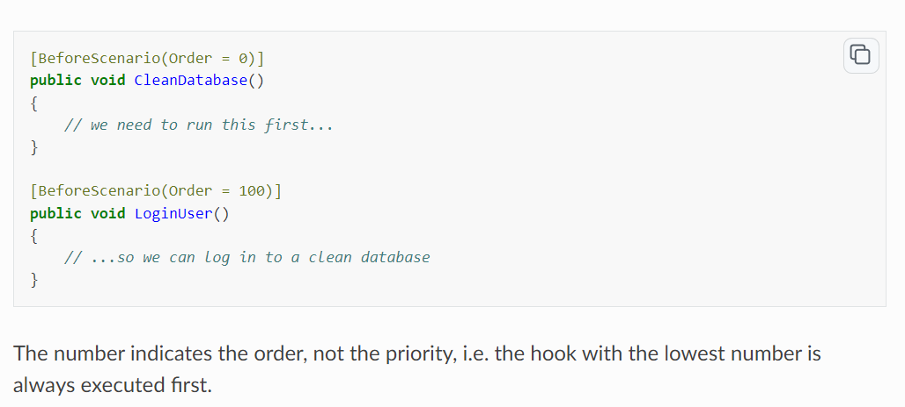

[Scope(Tag = "mytag", Feature = "feature title", Scenario = "scenario title")]

Feature: Calculator

* SpecRun.exe run Default.srprofile --basefolder c:\MyProjectFolder --outputfolder output --report MyReport.html

SpecFlow+ LivingDoc (closed-source): This is a**set of tools that renders your Gherkin Feature Files** in an easily readable format with syntax highlighting and allows you to quickly share and collaborate on Gherkin Feature Files with stakeholders that are not familiar with developer tools

[BeforeScenario(Order = 100)]

Scenario Outline: Add two numbers

Given I have entered <a> into the calculator

And I have entered <b> into the calculator

When I press add

Then the result should be <result> on the screen

@source:CalculatorExamples.xlsx

Examples:

| case | a | b | result |

[External Data Plugin — documentation (specflow.org)](https://docs.specflow.org/projects/specflow/en/latest/Guides/externaldata.html)

@ignore

@source

@DataSource, @DisableDataSource

@DataFormat=format is not identified

@DataField=change the Column name (c=p)

@DataSet = Sheetname

**Rest API:**

[Authenticators | RestSharp](https://restsharp.dev/authenticators.html#request-token)

[Monolithic vs Microservices architecture - GeeksforGeeks](https://www.geeksforgeeks.org/monolithic-vs-microservices-architecture/)

If all the functionalities of a project exist in a single codebase, then that application is known as a monolithic application.

Microservices are the small services that work together. Entire functionality divides.

Service oriented:

A Service-Oriented Architecture or SOA is a design pattern which is designed to build distributed systems that deliver services to other applications through the protocol.

[SOA - Service Oriented Architecture - javatpoint](https://www.javatpoint.com/service-oriented-architecture)

WSDL stands for Web Services Description Language. It is an XML-based definition language mainly used for describing the functionality of SOAP-based web services==soap

* Clients uses stubs / proxies.
* Client uses Stub creates a SOAP request.
* SOAP request is sent to Web Service skeleton.
* Web Service skeleton invokes the Web Service.
* Web Service uses Skeleton prepares SOAP response.
* SOAP response is interpreted by Stub.
* POST is NOT idempotent.
* GET, PUT, DELETE, HEAD, OPTIONS and TRACE are idempotent.

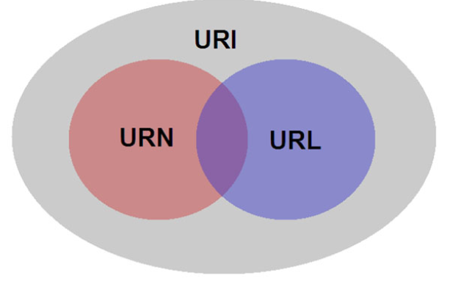

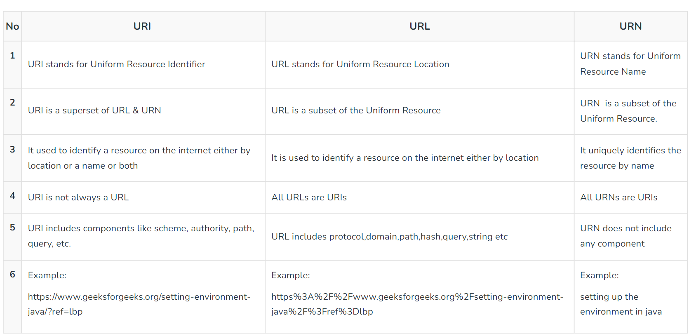

WADL stands for Web Application Description Language which is a machine-readable language consisting of XML descriptions, which is based on [HTTP](https://www.geeksforgeeks.org/http-full-form/) web services==Rest.

402—payment required.

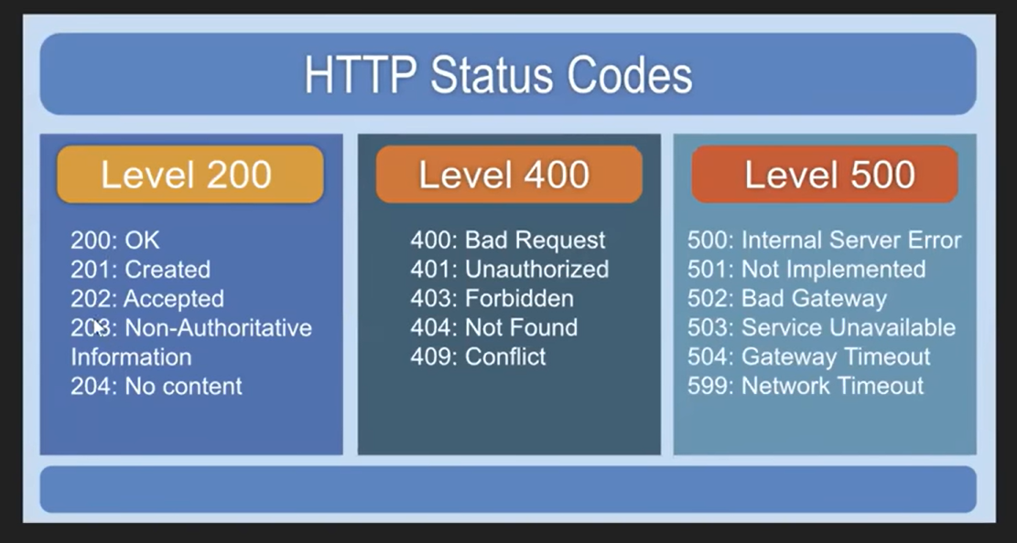

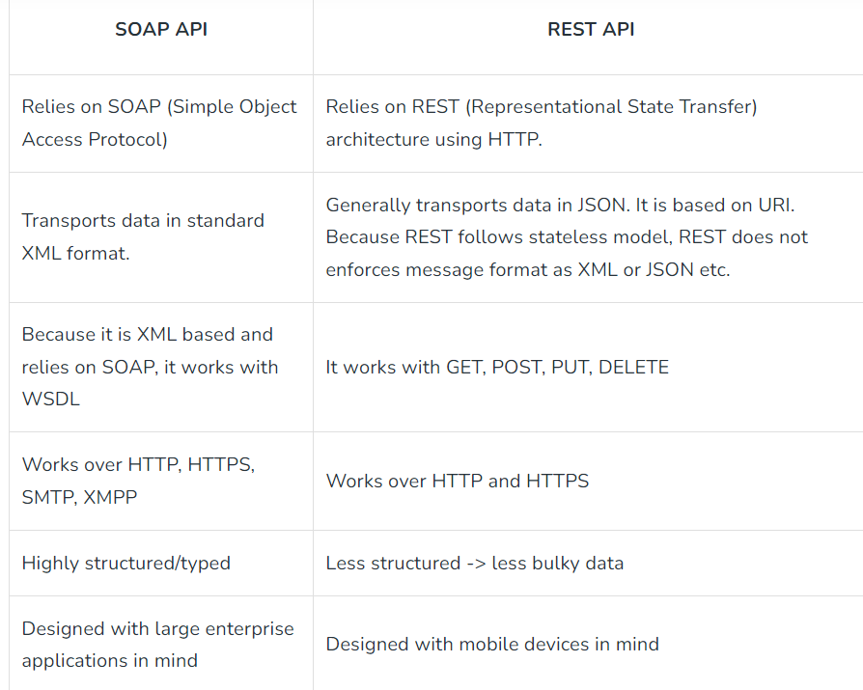

Rest constraints:

1. **Uniform interface.** Specific resources should be described by [**Uniform Resource Identifier**](https://www.baeldung.com/java-url-vs-uri) (URI).
2. **Client-server architecture**.
3. **Statelessness.** A RESTful API should be stateless. In simple words, it means that it doesn’t store any information about the user’s session. Therefore, every single request should provide complete data to process it. Thus, it leads to greater availability of the API.
4. **Cacheability.** The server’s response should provide information on whether it should be cached and for what time or not. [**Caching**](https://www.baeldung.com/spring-cache-tutorial) the data that updates rarely improves performance and eliminates redundant client-server interactions. When possible, resources should be cacheable on the client or server side.
5. **Layered system.** A REST API can consist of multiple layers, eg., business logic, presentation, data access. Moreover, layers shouldn’t directly impact others. Further, the client shouldn’t know if it’s connected directly to the end server or intermediary. Therefore, we can easily scale the system or provide additional layers such as gateways, proxies, load balancers.
6. **Code on demand**. This one is an optional constraint. The server can return a part of the code itself instead of the data in JSON format. The point is to provide specific operations on the data that the client can use directly. Although, it’s not a common practice

A Restful system consists of a:

* client who requests for the resources.
* server who has the resources.

**Components of a REST API**

A typical REST API consists of the following parts:

* URL
* Request Method
* Request Headers
* Request body
* Response Code
* Response Headers
* Response body

Tools:

1. Curl
2. Swagger
3. Soap UI
4. Api tester
5. HTTP request app
6. Pyresttest

OAuth 2.0 defines a protocol, i.e., specifies how tokens are transferred, JWT defines a token format.

**1. Session:**

It is the overall amount of time spent on an activity. (Server side) more secure.

**2. Cookie:**  
A cookie is a small text file that is saved on the user’s computer. The maximum file size for a cookie is 4KB. (Client side)

* **Session Cookies:** These cookies are active till the browser that triggers the cookie is open. When we close the browser this session cookie gets deleted
* **Persistent Cookies:** These cookies are written permanently on the user machine and it lasts for months or years

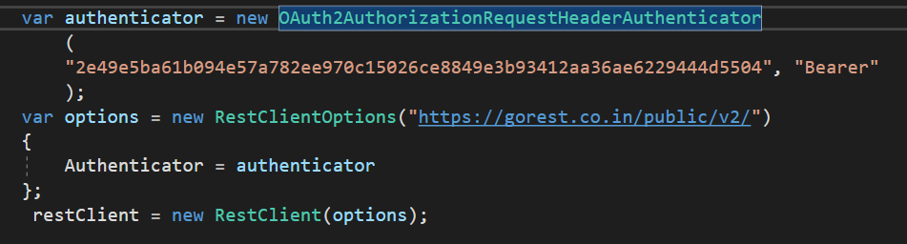

Payload issues (validation)

Deserialization Issues.

Authorization issues.

Advantages :

* Earlier validation of correctness in response and data.
* Earlier test maintenance.
* Better speed and coverage of testing.
* GUI independent testing.
* Reduced testing cost.
* Language independent test.
* Helpful in testing core functionality.

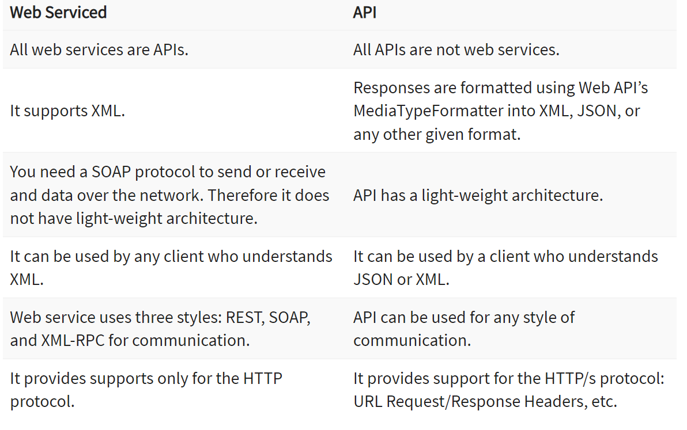

**Test Doubles:** A Test Double is an object that can stand-in for a real object in a test, like how a stunt double stands in for an actor in a movie.

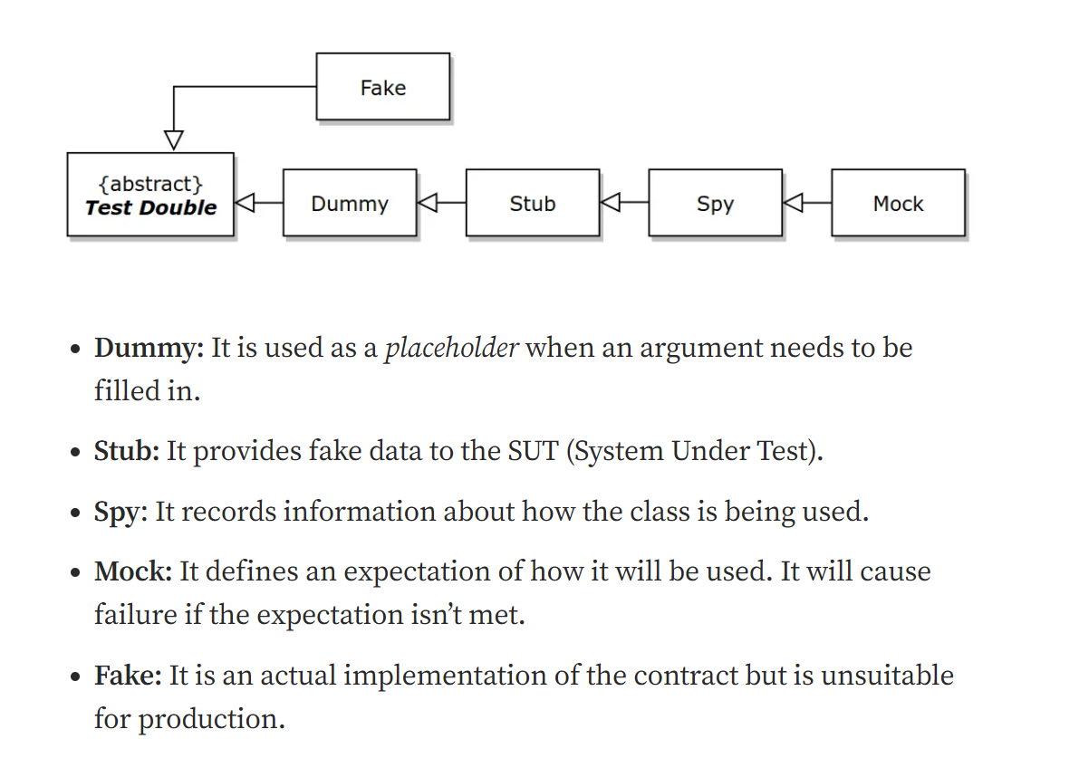

Git:

Undoing Changes:  
Working Directory: git checkout --filename / git checkout . / git clean -xfd / git clean -f  
Staging Area (indexing): git reset -- file.txt  
Local Branch: git reset HEAD^^ (HEAD~2) / git commit --amend -m "Message"  
Remote Repo: git revert <sha1>

Git Reset:  
git reset --soft: Commit to Index(Staging Area)  
git reset --hard: Delete the changes from Commit area  
git reset --mixed: Commit to File System

* Git reset -->move the tip of a branch to a different commit. This can be used to remove commits from the current branch. It moves the branch backwards by commits.
* Git Revert-->undoes a commit by creating a new commit. This is a safe way to undo changes, as it has no chance of re-writing the commit history.

WET (Write Everything Time)

DRY(Do not Repeat Yourself)

YAGNI(You Aren’t Gonna Need It)

KISS(Keep It Simple Stupid)

Automation Testing:

* Tests that are repetitive and time-consuming.
* Tests that run for multiple builds.
* Tests that are vulnerable to human error.
* Tests of high-risk, frequently used functions within the software.
* Tests that can’t be done manually.
* Tests that need to be run on multiple software or hardware configurations and platforms.
* Early bug detection, saves time and cost, better ROI, faster time to market.

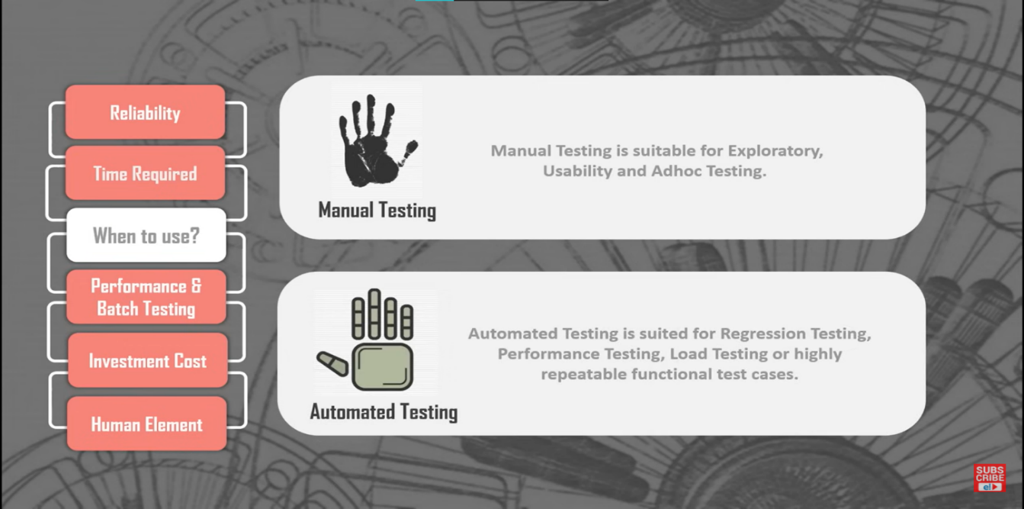

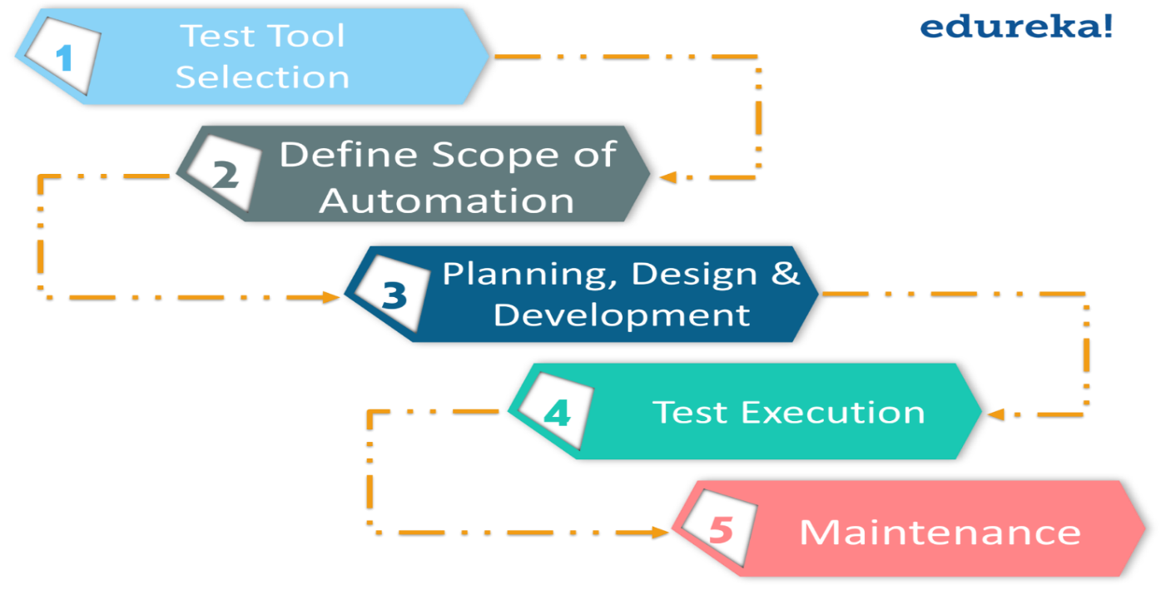

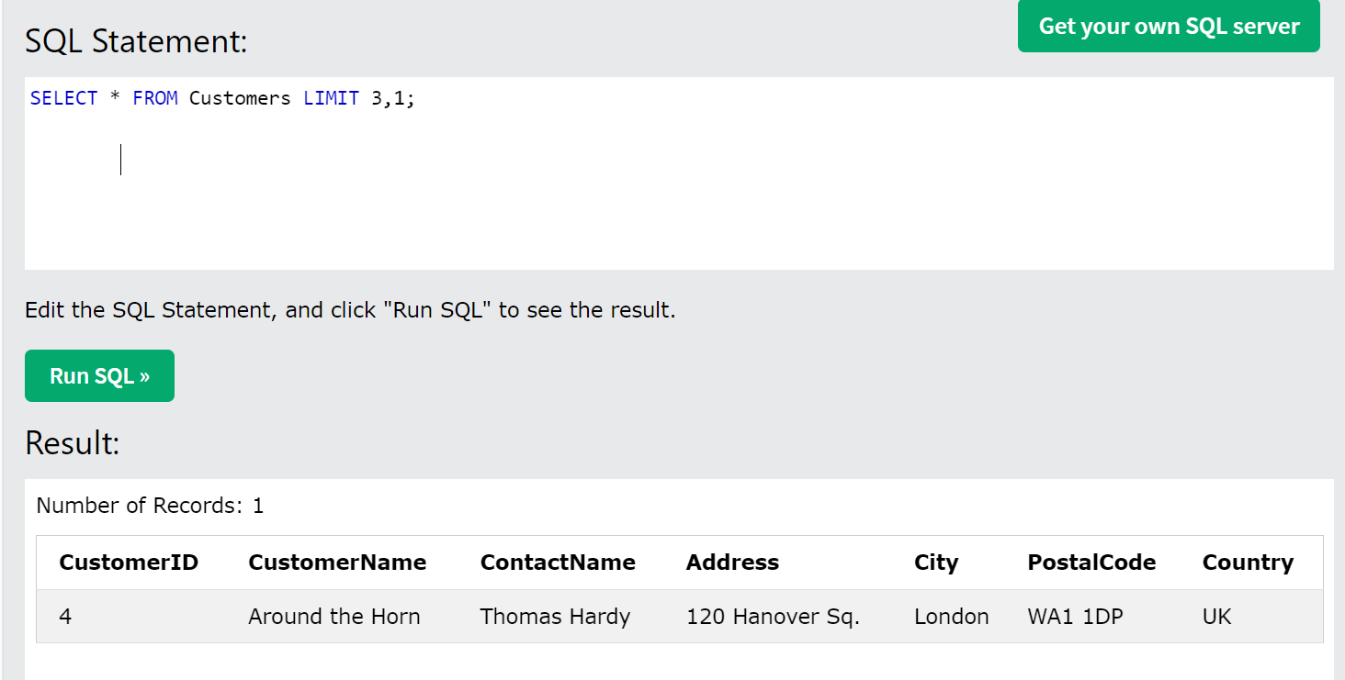

SELECT salary

FROM employee

ORDER BY salary desc limit n-1,1;

GRANT SELECT, INSERT, DELETE, UPDATE ON Users TO 'Amit'@'localhost;

[SQL Commands: DDL, DML, DCL, TCL, DQL - javatpoint](https://www.javatpoint.com/dbms-sql-command)

**Layers in Testing:**

1) **TestCaseLayer** 🡺 Feature File

2) **TestScript Layer 🡺** script for TestCase--->Binding Classes, step definiton

3) **TestFrameWork Layer** 🡺

Config

Source of Data

clients

Localization-->Globalization-->

common Things

utility

4) **TestDataLayer** 🡺

which break an application

data

dynamic data

if we don't clean (Clear,Reset) it 🡪 performanance issue, duplication issue, error

state should be same as before.

5) **Test Reporting Layer 🡺**

log4net

Extent Report

log, Organized way.

**MSBuild**, which stands for Microsoft Build Engine, is a platform for building applications. This toolset is used by Visual Studio on Windows and by .NET Core across all platforms. It helps automate the process of compiling the source code, packaging, testing, deploying, and creating documentation. MSBuild uses XML-based project files to control the build process, which define the items to build, as well as how and when they should be built.

### Setup

MSBuild comes integrated with Visual Studio. When Visual Studio is installed, MSBuild is also set up as part of the environment. It can also be used independently by installing the .NET SDK which includes MSBuild.

### Build Process

The MSBuild engine processes the project files (.csproj, .vbproj, etc.), which include instructions on how to build the application. The process generally involves:

1. **Parsing Project Files**: It reads the XML project files to understand what needs to be built and in what order.

2. **Loading Properties and Items**: It configures the environment based on properties (variables) and Items (files and data needed).

3. **Executing Tasks**: It carries out tasks like compiling code, copying files, executing tests, etc.

4. **Handling Target Dependencies**: Targets (a group of tasks) are executed in a specific order, respecting dependencies defined between them.

### Build Environment Setup

To set up MSBuild on a new machine, typically the following steps are involved:

1. **Install .NET SDK**: This installs MSBuild along with other necessary tools.

2. **Verify Installation**: Confirm MSBuild is accessible via the command line or terminal.

3. **Optional Editor/IDE Setup**: Install Visual Studio or other preferred editors that integrate with MSBuild.

### Dependencies within Solution

Dependencies within a solution in MSBuild are managed through project references. In a multi-project solution, project files can use `<ProjectReference>` elements to specify other projects in the solution that they depend on. MSBuild resolves these references and builds the projects in the correct order. Nuget package manager

### Dependencies Outside Solution

Dependencies outside a solution, like third-party libraries or packages, are often managed through package managers like NuGet. MSBuild integrates with tools like NuGet to restore and update packages, and it automatically handles the references during the build process.

### Tasks

Tasks in MSBuild are units of executable code used to perform build operations (like compiling code or copying files). Each task is represented by a `<Task>` element in the project file. MSBuild includes various built-in tasks, and custom tasks can also be created to extend functionality.

### Grouping Tasks

Tasks are grouped into **Targets**. Each Target can contain one or more tasks and can specify dependencies on other targets. For instance, a "Compile" target might depend on a "Clean" target. This grouping helps organize the build process logically and manage task dependencies.

### Conflicts between Different Versions of the Same Assembly

Conflicts can arise when different parts of a solution depend on different versions of the same assembly. MSBuild and the .NET environment address this using:

1. **Assembly Binding Redirection** in app.config or web.config files, where you specify which version of the assembly to use when there’s a conflict.

2. **NuGet’s Package Management**, which attempts to resolve version conflicts and ensure that compatible versions are used across all projects.

3. **Binding Redirects** can be automatically generated by MSBuild in some .NET project types to resolve these conflicts dynamically at build time.

Understanding how MSBuild works can significantly enhance your ability to effectively manage and troubleshoot .NET build processes, especially in complex multi-project environments.

dotnet clean -> dotnet restore -> dotnet build -> dotnet test -> dotnet run -> dotnet publish

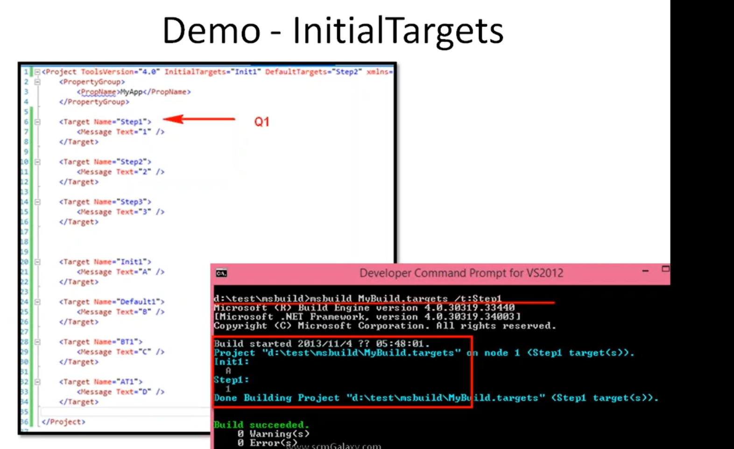

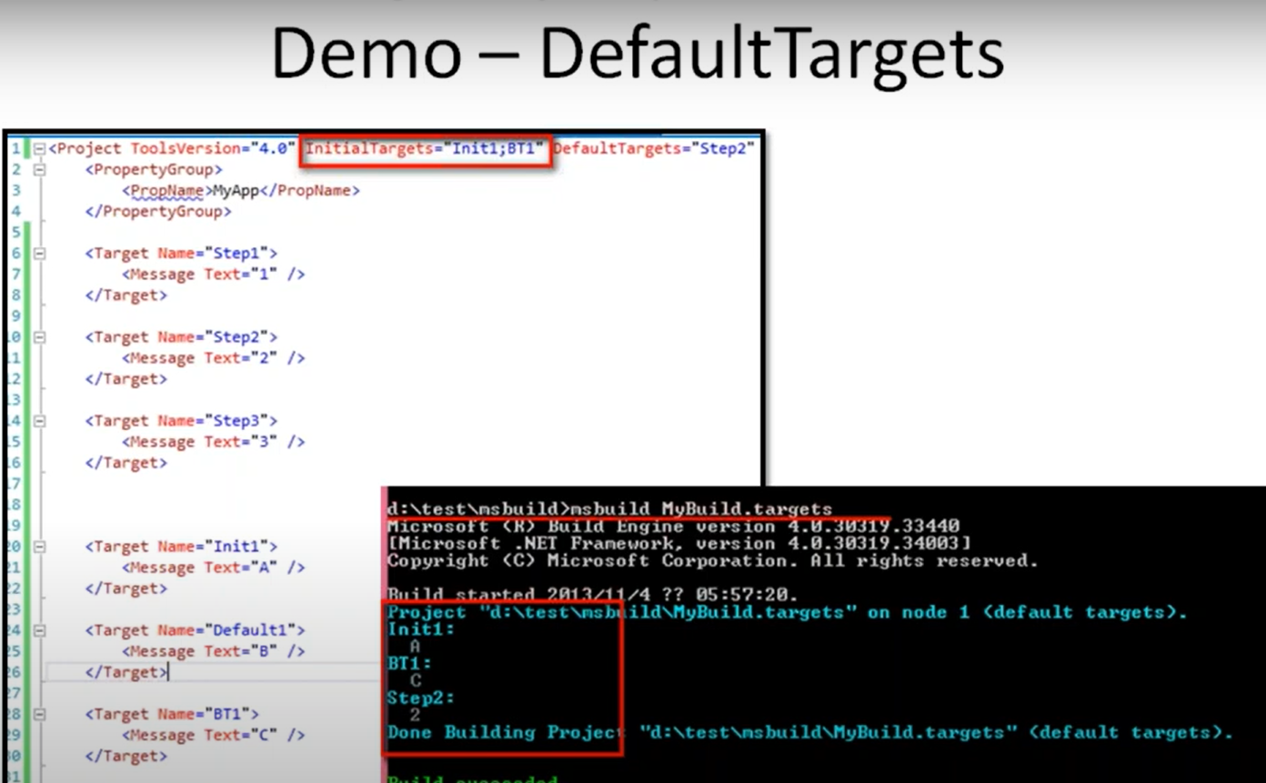

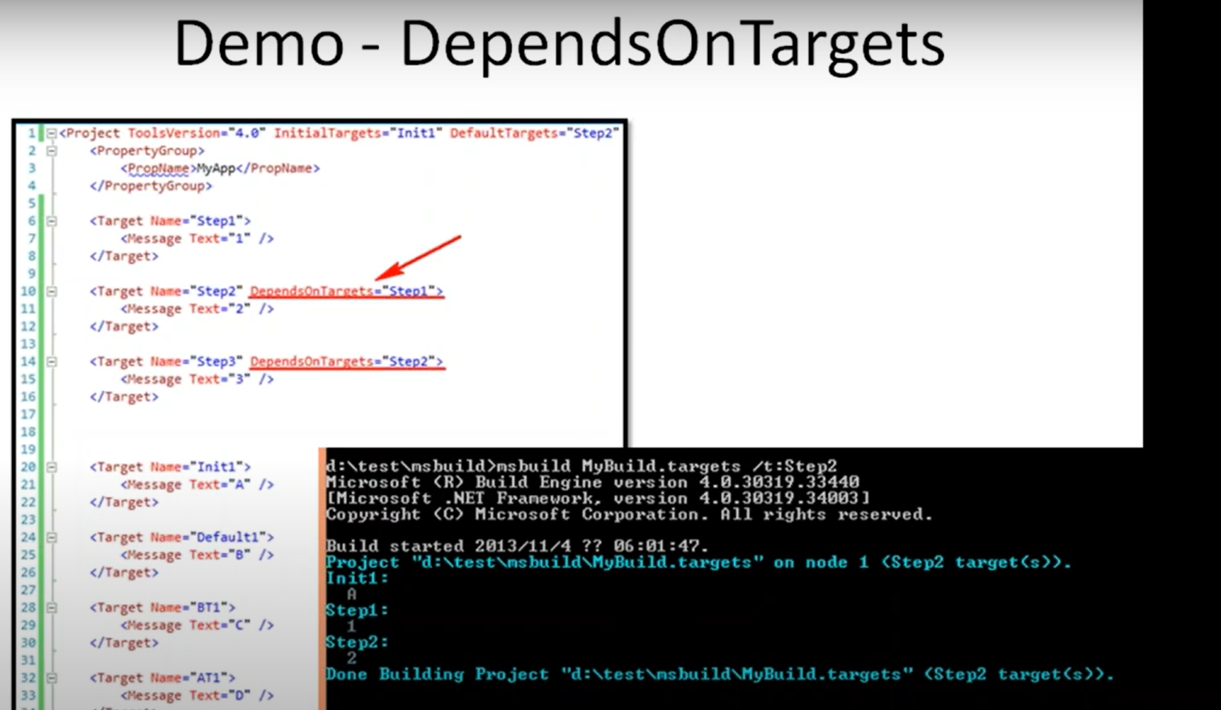

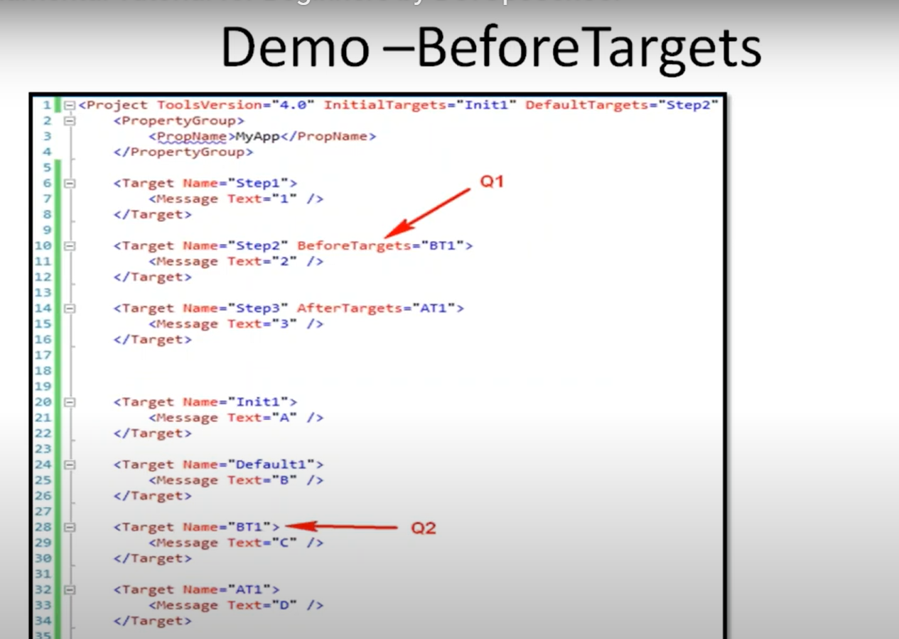

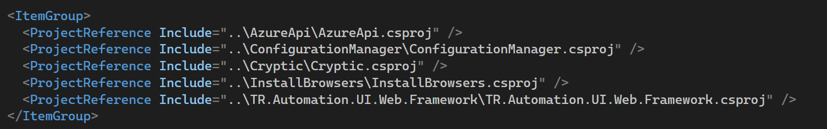

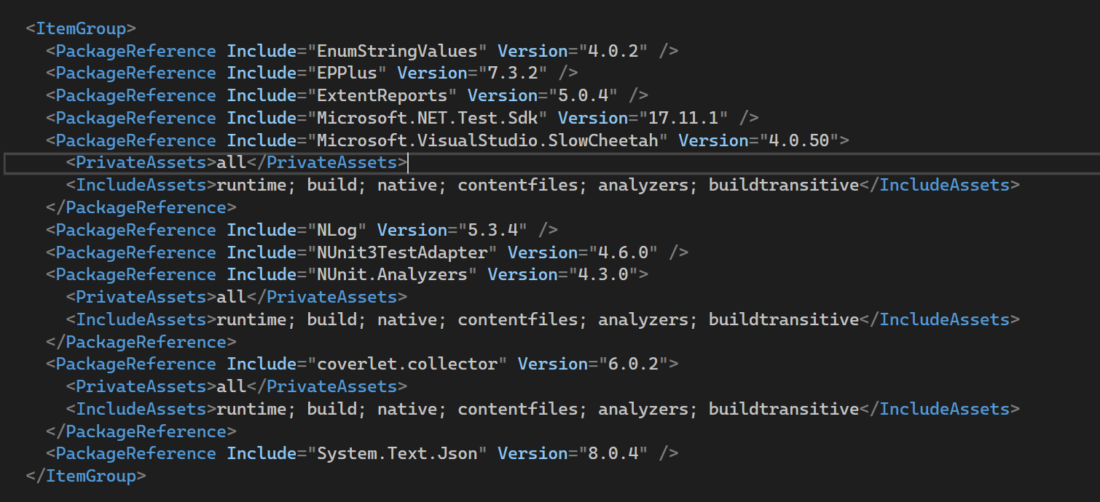

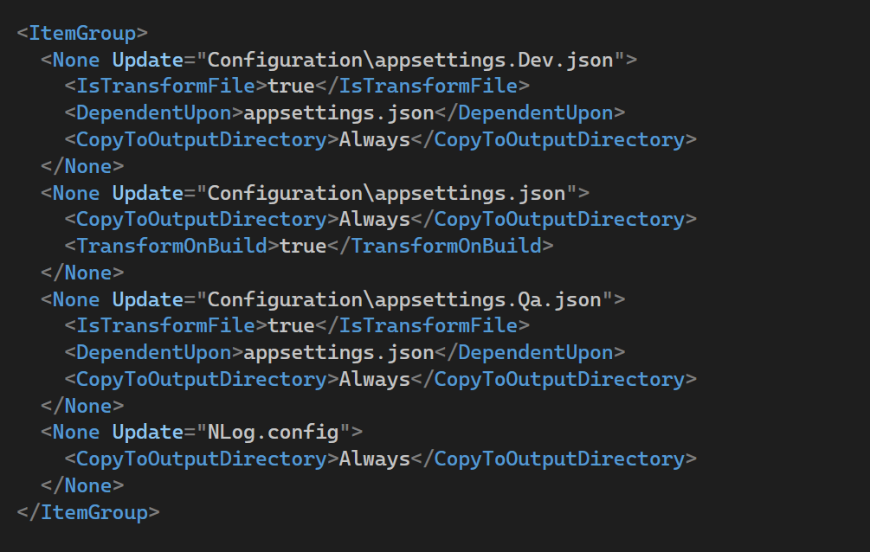

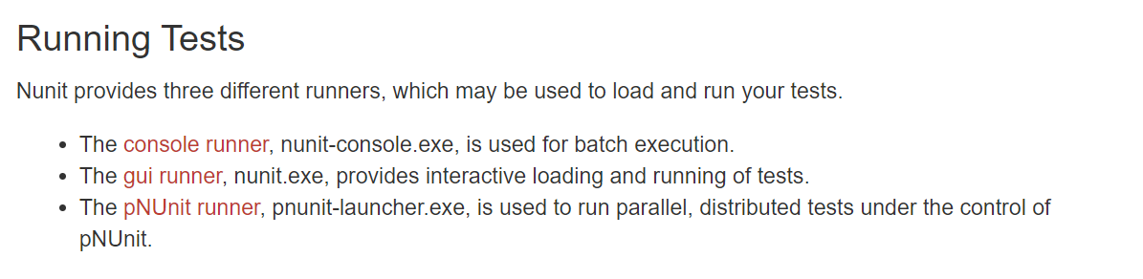

There are many more [Running Tests | NUnit Docs](https://docs.nunit.org/articles/nunit/running-tests/Index.html)

[MSBuild Tutorial: Install and create a project - MSBuild | Microsoft Learn](https://learn.microsoft.com/en-us/visualstudio/msbuild/walkthrough-using-msbuild?view=vs-2022)

<https://youtu.be/zjRmYV5psTg?si=e_hGSPsN_Bgc8O66>

ToLookup() - eager

GroupBy() – lazy

[LINQ Deferred Execution vs Immediate Execution in C# (dotnettutorials.net)](https://dotnettutorials.net/lesson/deferred-execution-vs-immediate-execution-in-linq/)

public class Parent

{

private Parent() { }

}

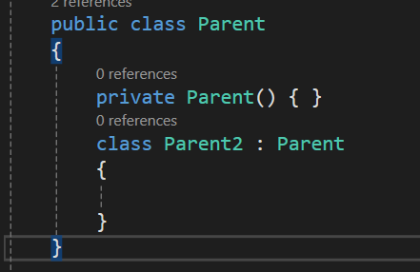

Design Patterns:

[Builder Design Pattern in C# with Examples - Dot Net Tutorials](https://dotnettutorials.net/lesson/builder-design-pattern/)

Nunit :

TestCaseSource

* It may be a field, property or method in the test class.
* It **must** be static.
* It must return an IEnumerable or a type that implements IEnumerable. For fields an array is generally used. For properties and methods, you may return an array or implement your own iterator.

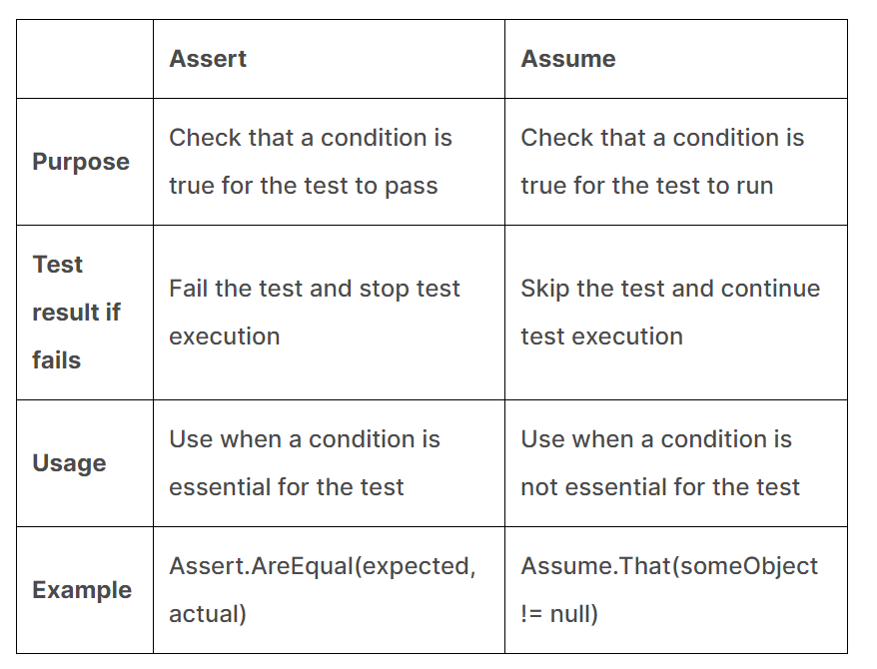

| **Aspect** | **Assume** | **Assert** |
| --- | --- | --- |
| **Purpose** | Used to ensure that prerequisites for a test are met | Used to verify conditions and expected results within the test |
| **Behavior on Failure** | If an assumption fails, the test is skipped, not marked as a failure | If an assertion fails, the test fails and is marked accordingly |

|  |  |  |
| --- | --- | --- |
|  | **TestFixture** | **TestSuite** |
| **Definition** | A class that contains one or more test methods. | A collection of TestFixture instances. |
| **Purpose** | To group related tests together and provide setup/teardown methods. | To organise tests into larger groups or hierarchies. |

**Constraint Model:**

The constraint-based Assert model uses a single method of the Assert class for all assertions.

* Assert.That(myString, Is.EqualTo("Hello"));

Uses:

* 1. Readability, clarity
  2. Flexibility, Extensibility – can create custom constraints
  3. We combine and asserts
     1. Assert.That(value, Is.LessThan(100).And.GreaterThan(50).Or.EqualTo(0));
  4. Improved error messages
  5. Easy to Learn

Special Asserts:

The special assertions do not check any condition.

* [Assert.Pass](https://docs.nunit.org/articles/nunit/writing-tests/assertions/special-assertions/Assert.Pass.html)
* [Assert.Fail](https://docs.nunit.org/articles/nunit/writing-tests/assertions/special-assertions/Assert.Fail.html)
* [Assert.Ignore](https://docs.nunit.org/articles/nunit/writing-tests/assertions/special-assertions/Assert.Ignore.html)
* [Assert.Inconclusive](https://docs.nunit.org/articles/nunit/writing-tests/assertions/special-assertions/Assert.Inconclusive.html)

The **Assert.Inconclusive** method indicates that the test could not be completed with the data available. (Skips the test)

Multiple Assertions:

1. The multiple assert block may contain any code, not just asserts.
2. Multiple assert blocks may be nested. Failure is not reported until the outermost block exits.
3. If the code in the block calls a method, that method may also contain multiple assert blocks.
4. The test will be terminated immediately if any exception is thrown that is not handled. An unexpected exception is often an indication that the test itself is in error, so it must be terminated. If the exception occurs after one or more assertion failures have been recorded, those failures will be reported along with the terminating exception itself.
5. Assert.Fail is handled just as any other assert failure. The message and stack trace are recorded but the test continues to execute until the end of the block.
6. An error is reported if any of the following are used inside a multiple assert block:
   * Assert.Pass
   * Assert.Ignore
   * Assert.Inconclusive
   * Assume.That
7. Use of Warnings (Assert.Warn, Warn.If, Warn.Unless) is permitted inside a multiple assert block. Warnings are reported normally along with any failures that occur inside the block.

Assert. Throws : pass when expected exception occurs

* Assert.Throws<ArgumentException>( () => throw new ArgumentException()); //pass
* Assert.Throws<Exception>(

() => throw new ArgumentException()); //fail

**Assert.Catch** is similar to **Assert.Throws** but will pass for an exception that is derived from the one specified.

* Assert.Catch<Exception>(

() => throw new ArgumentException()); -pass

* Assert.Catch(

() => throw new ArgumentException()); -pass by default it is exception class

Assert.Catch(

() => Console.WriteLine("print")); -fail should always return exception

**Test Context:**

The TestContext class allows tests to access certain information about the execution context.

It is a NUnit.Framework instance.The TestContext class is used to access a variety of information about the test run, such as the test fixture, test case, and environment.

TestContext.CurrentContext

* Test.FullName: The fully qualified name of the test being run.
* Test.Name: The name of the test being run.
* Test.Properties: A collection of key/value pairs representing properties of the test.
* TestDirectory: The directory containing the test assembly.
* WorkingDirectory: The current working directory for the test run.
* RandomSeed: The random seed used for generating random data in the test run.

Nunit Test Runners:

In NUnit, a test runner is a tool that is used to execute NUnit tests and report the results.

including the console runner, the NUnit GUI runner, and various third-party runners that integrate with popular IDEs like Visual Studio and JetBrains Rider.

nunit3-console.exe C:\JenkinsWorkspace\a\bin\release\net6.0-windows\UltraTaxCSTests.dll --test=UltraTaxCSTests.Tests.DeliveryTests.CheckPrintToMultipleLocationsTest

**1. NUnit Console Runner**

* **Description**: The NUnit Console Runner is a command-line tool that allows for running tests from the console (command prompt or terminal). It is handy for integration into Continuous Integration (CI) pipelines.
* **Usage**: You can specify various command-line options to control which tests are run, how results are reported, and more. It can generate reports in various formats that can be used for further analysis or for integration with CI systems.

**2. NUnit GUI Runner**

* **Description**: The NUnit GUI Runner is a graphical user interface that allows for a more visual interaction with your tests. You can see a tree structure of your tests, run them selectively, and view detailed results directly in the GUI.
* **Usage**: This runner is particularly useful during development when you want to run specific tests quickly without needing to use the command line. It also has features like debugging and setting breakpoints.

**3. Test Adapter for Visual Studio**

* **Description**: The NUnit Test Adapter allows you to run NUnit tests from within Visual Studio's Test Explorer. It integrates NUnit with Visual Studio, making it easier to run and debug tests without leaving the IDE.
* **Usage**: After installing the adapter, your NUnit tests appear in Visual Studio’s Test Explorer just like MSTest or xUnit tests would. This allows you to execute tests and even run them as part of Visual Studio's automated build and test cycles.

**4. ReSharper NUnit Integration**

* **Description**: If you use ReSharper, an extension for Visual Studio, it has built-in support for running NUnit tests. ReSharper enhances the test-running capabilities within Visual Studio, offering additional features such as running a subset of tests when code changes.
* **Usage**: ReSharper provides a test runner within Visual Studio that is similar to the Test Explorer but with enhanced functionality. It supports running tests in parallel, rerunning failed tests, and more comprehensive navigation features.

**5. Rider (JetBrains)**

* **Description**: Rider, a cross-platform IDE from JetBrains, supports NUnit natively without requiring additional plugins or adapters. Similar to ReSharper, it offers sophisticated tools for running and debugging NUnit tests.
* **Usage**: Tests can be run directly within the IDE, and it provides tools for analyzing test coverage, profiling tests, and more.

**6. Continuous Integration Servers**

* **Description**: Most CI servers like Jenkins, TeamCity, Travis CI, and others can execute NUnit tests as part of the build process, often using the NUnit Console Runner or through plugins that integrate NUnit.
* **Usage**: Typically, you set up your CI pipeline to invoke the NUnit console runner, possibly using a script, and then use the results (often XML files) to produce reports or make decisions about build success or failure in your pipeline.

Without parallelizable test class execute first and then parallel classes

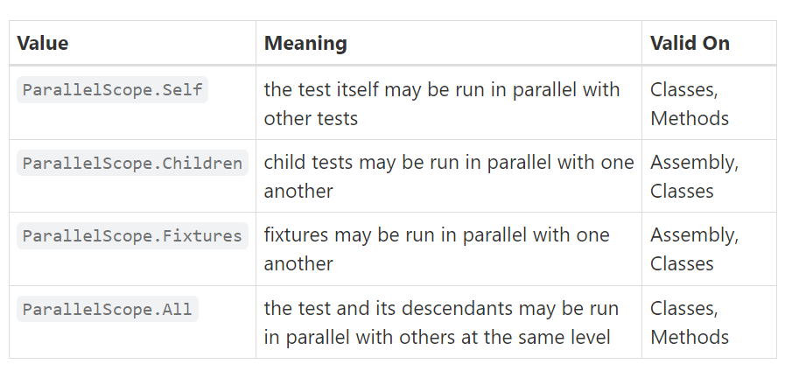

Self: child won’t run in parallel. Class run parallel with other class with all attribute,

Children : only child tests run in parallel but not classes

Fixtures: both classes should have fixtures, only clases run in parallel but tests run sequentially

<https://youtu.be/SijfIlw5sPM?si=JgIyKKxFyhn2znNr>

questions:

one class with All and other with Fixture – both classes execute at same time.

Self Vs Fixtures

